VIETNAM NATIONAL UNIVERSITY-HANOI
UNIVERSITY OF LANGUAGES AND INTERNATIONAL STUDIES

NGUYỄN VĂN THẮNG

EXPLORING TERTIARY EFL LEARNERS’ EXPERIENCES
WITH TECHNOLOGICAL TOOLS IN THEIR FOREIGN LANGUAGE LEARNING: A POSITIVE PSYCHOLOGY PERSPECTIVE
(Khám phá trải nghiệm của người học tiếng Anh bậc đại học với các công cụ công nghệ trong quá trình học ngoại ngữ: Góc nhìn tâm lý học tích cực)

Major: English Language Teaching Methodology
Code: 9140231.01

SUMMARY OF DOCTORAL THESIS

HA NOI, 2026

The study was conducted at
University of Languages and International Studies, VNU

Supervisors | : | 1. Prof. Dr. Hoang Van Van  2. Dr. Huynh Anh Tuan
Reviewer 1: ……………………………………………
Reviewer 2: ……………………………………………
Reviewer 3: ……………………………………………

Luận án sẽ được bảo vệ trước Hội đồng chấm luận án tiến sĩ họp tại:
Trường Đại học Ngoại ngữ, Đại học Quốc gia Hà Nội
vào hồi giờ ngày tháng năm 2026

Có thể tìm hiểu luận án tại:
Thư viện Quốc gia Việt Nam
Trung tâm Thông tin - Thư viện, Đại học Quốc gia Hà Nội

CHAPTER 1: INTRODUCTION
1.1. Background to and rationale for the study
Positive psychology (PP) emerged as an approach that foregrounds the resources, qualities, and conditions enabling people to function and develop optimally, rather than concentrating solely on deficits or disorders. In education, this orientation broadens the aims of learning beyond scores and knowledge acquisition to encompass holistic development, including Positive emotions, motivation, supportive relationships, meaning, and a sense of progress. This shift is particularly important in foreign language learning because language learning is not merely a cognitive process; it is also an emotional, social, and identity-related experience. Learners repeatedly face uncertainty, the possibility of making errors, feelings of being evaluated, and a gap between their current competence and communicative demands. Enjoyment, confidence, persistence, belonging, and a sense of purpose may therefore determine whether they continue to invest in learning.
Seligman (2011) conceptualises human flourishing through the PERMA model, which comprises five closely interrelated elements: Positive emotions, Engagement, Relationships, Meaning, and Accomplishment. The model offers a multidimensional lens for examining learning experiences and avoids reducing positive psychology to momentary happiness. In the context of English as a foreign language, PERMA enables simultaneous analysis of learners’ emotions, investment in tasks, social support, personal purposes, and perceptions of progress. Nevertheless, comprehensive applications of PERMA to English language learners in Vietnam remain limited, particularly among non-English-major undergraduates.
Alongside the development of PP, technology has become a permanent component of the foreign language learning ecology. The COVID-19 pandemic accelerated this transformation when universities were compelled to shift rapidly to remote teaching. After the emergency period, online platforms, multimedia resources, language-learning applications, digital games, electronic dictionaries, and artificial intelligence tools continued to be integrated into everyday learning. For students, technology can provide access to authentic input, flexible practice, immediate feedback, private rehearsal, connections with teachers and peers, and more visible indications of progress. These affordances have the potential to influence the PERMA elements directly.
Technology, however, does not automatically produce positive experiences. Disconnections, unstable devices, information overload, digital distraction, limited social presence, ambiguous feedback, and overreliance on machine translation or AI can undermine emotions, engagement, relationships, meaning, and accomplishment. The same tool may support deep learning in one situation yet replace thinking in another. The central question is therefore not whether technology is inherently “good” or “bad”, but how learners use it, under what conditions, and through which mechanisms positive psychological experiences are fostered or impeded.
This study arose from the need to understand in depth the experiences of non-major EFL students at a Vietnamese university. This large group studies English as a compulsory subject and commonly has to balance language learning with the demands of their disciplinary programmes. Listening to their stories clarifies not only which tools they use, but also how technology enters their learning lives and reshapes their emotions, habits, relationships, and future orientations.
1.2. Statement of the research problem
Most studies of technology in foreign language learning have focused on technology acceptance, skill development, test performance, or general motivation. Meanwhile, many PP studies in second language acquisition have examined individual variables such as enjoyment, anxiety, confidence, or resilience. What remains lacking is an integrated analysis of how technological tools influence all five PERMA elements, including both facilitative and impeditive influences. This gap is especially evident in Vietnamese higher education and among non-major EFL learners.
1.3. Aim, objectives, and research questions
The overall aim of the dissertation is to explore how technological tools shape the positive psychological experiences of non-major EFL students in their foreign language learning, through Seligman’s (2011) PERMA framework. Technology is not treated as a homogeneous independent variable, but as a set of resources that learners select, combine, and use in different contexts.
The specific objectives are: (1) to investigate how technological tools foster learners’ Positive emotions, engagement, relationships, meaning, and accomplishment; and (2) to investigate how technological tools impede or weaken these five elements.
The study addresses the following two research questions:
(a) How do technological tools foster non-major EFL learners’ positive psychology in terms of Positive emotions, engagement, relationships, meaning, and accomplishment in their foreign language learning?
(b) How do technological tools impede non-major EFL learners’ positive psychology in terms of the five PERMA elements in their foreign language learning?
1.4. Scope of the study
The study was conducted at a Vietnamese university with 15 first-, second-, and third-year students enrolled in compulsory Basic English courses. The participants majored in Traditional Medicine, Pharmacy, Law, Economic Law, and Business Administration. The dissertation focuses on their experiences with five categories of tools: multimedia resources; digital games and gamified applications; mobile language-learning applications; online learning platforms and collaborative tools; and AI, translation, dictionary, grammar, and pronunciation tools. The study does not seek to measure the effect of a single technological intervention or statistically generalise to all Vietnamese students. Its focus is the meanings that learners attribute to their experiences within a particular context.
1.5. Significance of the study
Theoretically, the study connects three fields that have often been examined separately: positive psychology in second language acquisition, technology-enhanced language learning, and narrative inquiry. PERMA is applied not simply as a list of five positive outcomes, but as a dynamic system in which change in one element can spill over into others. Immediate feedback, for example, may create relief and confidence, which increase engagement; sustained engagement can generate visible progress; and progress can strengthen meaning and accomplishment. Conversely, technical failures may cause anxiety, disrupt concentration, prevent interaction, and make assessment outcomes fail to reflect genuine competence.
Methodologically, the study uses narrative frames to enable participants to recount stages, memorable events, changes over time, and contradictory experiences. This approach complements cross-sectional surveys by illuminating mechanisms, contexts, and learners’ processes of interpretation. Hybrid coding balances the pre-existing PERMA framework with meanings emerging from the data, thereby reducing the risk of forcing learners’ stories into predetermined categories.
Practically, the findings assist teachers in selecting and designing technology-mediated activities on the basis of experiential quality rather than novelty or tool popularity alone. The dissertation also offers implications for administrators, teacher educators, and students concerning infrastructure, digital competence, attention management, feedback, social presence, and responsible AI use.
1.6. Research methodology and structure of the dissertation
The dissertation adopts a qualitative approach within a constructivist-interpretivist paradigm and employs narrative inquiry as its primary methodology. Data were collected mainly through narrative frames containing prompts while leaving participants room to elaborate freely. Follow-up interviews were used to clarify ambiguities and check interpretations. The data were analysed using Braun and Clarke’s (2006) thematic analysis, combining inductive and deductive coding. The dissertation comprises six chapters: Introduction; Literature Review; Methodology; Facilitative Influences; Impeditive Influences; and Conclusion.
CHAPTER 2: LITERATURE REVIEW
2.1. Technological tools in foreign language learning
In this dissertation, technological tools are understood as digital devices, applications, platforms, resources, and features that learners use to access language, practise, communicate, receive feedback, manage progress, or complete tasks. The concept extends beyond formally prescribed educational software because students’ foreign language learning takes place within an ecology comprising both institutionally required tools and resources selected independently by learners. A YouTube video, a Zalo group, Cambridge Dictionary, Duolingo, Zoom, or ChatGPT can all become learning tools when mobilised for language-related purposes.
The first category comprises multimedia resources. Videos, podcasts, songs, films, TED Talks, TikTok content, and English-learning channels provide rich audiovisual input, communicative contexts, and pronunciation models. The ability to pause, replay, adjust playback speed, and activate subtitles enables learners to regulate difficulty. When content connects with personal interests, multimedia also bridges English learning and everyday life. However, excessive content, rapid delivery, or overdependence on subtitles can produce overload and superficial processing.
The second category consists of digital games and gamified applications. Points, levels, badges, learning streaks, leaderboards, and short challenges transform practice into manageable goals that are easier to initiate. These features can lower pressure, sustain habits, and signal progress. Conversely, when learners focus only on preserving streaks, collecting rewards, or finishing quickly, gamification may replace deep-learning goals with the maintenance of surface-level performance indicators.
The third category includes mobile language-learning applications and spaced-repetition systems. Duolingo, Quizlet, Memrise, Anki, Cake, ELSA Speak, and similar applications support anytime learning, content chunking, and personalised pacing. They are particularly suitable for non-major learners, who often have only brief periods available between disciplinary classes. Nevertheless, learning fragmented into numerous very short sessions may be insufficient for deep processing unless it is accompanied by integrative tasks and opportunities for transfer.
The fourth category comprises online learning platforms and collaborative tools, including Zoom, Microsoft Teams, Google Meet, Google Classroom, learning management systems, Google Docs, Padlet, and social-media groups. They support class organisation, assignment distribution and submission, feedback, discussion, collaborative writing, and group coordination. Their psychological value depends heavily on teacher presence, communication norms, task structure, and infrastructural reliability. An online class may expand participation opportunities but may also make learners feel invisible, isolated, or fatigued.
The fifth category includes AI, machine translation, dictionaries, and grammar- and pronunciation-support tools. ChatGPT, Gemini, Google Translate, Grammarly, ELSA Speak, YouGlish, and online dictionaries can provide explanations, examples, error diagnoses, wording suggestions, and pronunciation models. These tools reduce information-search costs and allow private rehearsal before public communication. Yet the boundary between support and the replacement of thinking is delicate. Their effectiveness depends on how much cognitive and linguistic work learners continue to perform before, during, and after receiving tool-generated output.
2.2. Benefits and challenges of technology
Previous research indicates that technology can increase autonomy, accessibility, personalisation, interaction, and feedback. These benefits, however, are not fixed properties of a tool. They emerge only when tasks are appropriate, learners possess self-regulatory competence, feedback is comprehensible, and the social environment is sufficiently supportive. Conversely, technology may cause attentional fragmentation, cognitive overload, social-comparison pressure, privacy loss, dependence on automation, and unequal access. The dissertation therefore adopts an affordance perspective: tools open possibilities, but outcomes are produced through the interaction of design, task, learner, and context.
2.3. Positive psychology and the PERMA model
Positive psychology examines the conditions that enable individuals and communities to function well, including Positive emotions, strengths, resilience, hope, high-quality relationships, and purpose. In language education, this perspective does not deny anxiety, failure, or difficulty. Rather, it advances a more balanced view in which positive resources can coexist with negative emotions and assist learners in responding to challenge. This is especially appropriate to foreign language learning, where learners often experience enjoyment and fear of error, curiosity and insecurity, pride and disappointment at the same time.
2.3.1. Positive emotions (P)
Positive emotions in this study include enjoyment, interest, curiosity, relief, pride, gratitude, and a sense of safety. According to Broaden-and-Build Theory, positive emotions can broaden attention and action repertoires while building longer-term resources such as confidence, relationships, and resilience. In foreign language learning, an enjoyable moment does not automatically constitute deep learning, but it can reduce avoidance and make learners more willing to try, make errors, and return to a task.
2.3.2. Engagement (E)
Engagement is understood as sustained, high-quality investment in learning activity. The dissertation analyses four dimensions: behavioural, cognitive, affective, and agentic engagement. Behavioural engagement is reflected in time on task, persistence, participation, and completion. Cognitive engagement involves planning, monitoring, deep processing, and self-correction. Affective engagement refers to sustained interest, absorption, and willingness to remain emotionally invested in an activity. Agentic engagement occurs when learners proactively seek support, personalise tools, and help shape tasks.
A necessary distinction is made between Positive emotions and affective engagement. Enjoyment or relief may be an immediate reaction to an interesting video or a correct answer; affective engagement requires more sustained involvement, evidenced when learners repeatedly return, maintain interest, and invest emotionally across activities or over time. The two constructs may develop sequentially, but they are not identical.
2.3.3. Relationships (R)
Relationships refer to feeling supported, recognised, and included in a learning community. In foreign language learning, relationships with teachers, peers, and English-using communities provide feedback, encouragement, and opportunities for authentic interaction. Technology can extend these relationships beyond class time, but it may also remove non-verbal cues, increase misunderstanding, and make learners feel unseen.
2.3.4. Meaning (M)
Meaning is the perception that learning English serves a valued purpose beyond completing a course. Meaning may derive from access to disciplinary knowledge, intercultural communication, an identity as an English user, career aspirations, or participation in wider communities. Technology contributes to meaning when it brings learners closer to authentic situations, products, and users.
2.3.5. Accomplishment (A)
Accomplishment is the sense of attaining goals, making progress, and mastering competence. In digital environments, scores, levels, charts, feedback, and stored products make progress more visible. However, accomplishment has enduring psychological value only when such signals reflect genuine capability. High scores obtained through copying, wholesale translation, or technically flawed assessment can produce distorted indicators of achievement.
PERMA is treated in the dissertation as an interactive system. Positive emotions may initiate engagement; engagement creates opportunities to build relationships and progress; supportive relationships enhance meaning; meaning helps learners persist through difficulty; and accomplishment in turn strengthens confidence and Positive emotions. This interconnection permits a fuller explanation of technology’s cascading effects.
2.4. Mechanisms linking technology and PERMA
The literature indicates that technology’s psychological influences are commonly produced through several mediating mechanisms. First, low-stakes practice allows learners to attempt tasks repeatedly without public evaluation. Short exercises, games, chatbots, or private pronunciation practice reduce the emotional cost of error. This lowered threat produces relief and confidence, increasing the likelihood that learners will attempt more demanding tasks.
Second, immediate feedback narrows the interval between action and information about outcomes. When feedback is specific and actionable, learners can identify errors, correct them promptly, and see the relationship between effort and progress. This mechanism supports Positive emotions, cognitive engagement, and accomplishment. By contrast, overly general, contradictory, or unexplained feedback can increase doubt and weaken trust in assessment.
Third, private rehearsal enables learners to prepare language before communicating with others. Using AI to generate possible questions, listen to pronunciation models, test responses, or revise a draft can reduce anxiety and improve the quality of participation. Rehearsal is developmental only when learners continue to generate, evaluate, and adapt language themselves; when the tool produces the entire product, rehearsal becomes a substitute for learning activity.
Fourth, autonomy and personalisation allow learners to select content, pace, timing, tools, and challenge level. When these choices align with needs, technology strengthens control and agency. Too many options or insufficient guidance, however, may create decision overload and diffuse learning goals.
Fifth, authentic input and interaction with real communities make English purposeful. Videos, podcasts, international forums, online clubs, and communication with people from other countries help learners perceive English as a means of accessing knowledge, culture, and careers rather than merely a test subject. This mechanism is especially relevant to Meaning and Relationships.
Sixth, visible progress turns small improvements into concrete evidence. Learning streaks, revision histories, pronunciation records, levels, and before-and-after products can strengthen accomplishment and competence beliefs. Digital indicators nevertheless need to be combined with qualitative evaluation because the quantity of completed exercises does not necessarily represent deep language competence.
2.5. Barriers in technology-supported foreign language learning
Previous literature shows that technical failures disrupt concentration and increase stress; digital distraction competes with learning goals; unsuitable design creates cognitive overload; weak social presence reduces perceived support; and automated assessment may lack transparency. AI also introduces new challenges concerning authorship, accuracy, dependence, and the replacement of thinking. These barriers rarely operate in isolation. An audio failure, for example, may simultaneously cause frustration, prevent interaction, and leave a speaking performance unassessed, thereby affecting P, E, R, and A at once.
2.6. Previous studies and research gaps
International research has documented relationships among enjoyment, emotional intelligence, anxiety, and foreign language outcomes, while also showing that gamification, mobile learning, automated feedback, and online platforms can increase motivation and participation. Nevertheless, many studies employ quantitative designs, measure a limited number of variables at a single point, and treat a tool as a homogeneous causal agent. Vietnamese studies have examined attitudes towards online learning, mobile applications, learning management systems, and AI, but have largely concentrated on usefulness, acceptance, or skill outcomes.
Three principal gaps were identified. First, few studies apply the complete PERMA model to examine emotional, behavioural, relational, purposeful, and accomplishment-related dimensions together. Second, balanced analysis of facilitative and impeditive influences is limited, particularly regarding the mechanisms linking technological affordances to psychological experience. Third, the temporally situated voices of Vietnamese non-major EFL students remain insufficiently represented. The present study addresses these gaps through a narrative design, cross-case analysis, and a conceptualisation of technology as a personalised ecology.
2.7. Theoretical and conceptual frameworks
PERMA was selected for three reasons. First, it offers a sufficiently broad structure for analysing learner flourishing through five distinguishable yet interacting dimensions. Second, its elements correspond directly to foreign language learning experience: emotions during tasks; quality of participation; relationships with teachers, peers, and communities; purposes for using language; and perceived progress. Third, PERMA makes it possible to evaluate technology beyond technical efficiency or scores by asking whether technology enables learners to learn well and experience greater well-being while learning.
Oxford’s EMPATHICS is a rich, language-specific framework encompassing emotions, motivation, perseverance, agency, time, strengths, identity, and connectedness. The present study nevertheless selected PERMA because of its parsimony, clear operationalisability, and fit with the two symmetrical research questions concerning facilitation and impediment. PERMA was not used to exclude factors beyond the model. Inductive codes, contradictory cases, and experiences that did not fit neatly within the five categories were retained and examined during analysis.
The conceptual framework positions technological tools within a non-linear relationship. Five categories of technology—multimedia, gamification, mobile applications, online platforms, and AI—may exert facilitative or impeditive influences on the five PERMA dimensions. The implied bidirectionality indicates that effects depend on patterns of use, learner competence, task design, teacher presence, infrastructure, and temporal context. The same application may create enjoyment through low-stakes practice yet generate pressure through streak requirements; AI may scaffold a difficult paragraph yet also replace the learner’s production of the entire text.
The framework guided data collection and analysis without predetermining the findings. During initial coding, narrative excerpts were assigned codes close to participants’ language and the function of the tool, such as “subtitled video enables replay”, “immediate feedback reduces fear of error”, “notifications interrupt concentration”, or “wholesale translation prevents vocabulary retention”. Codes were subsequently grouped into themes and examined in relation to PERMA. This two-way process created space for emergent data while maintaining theoretical coherence.
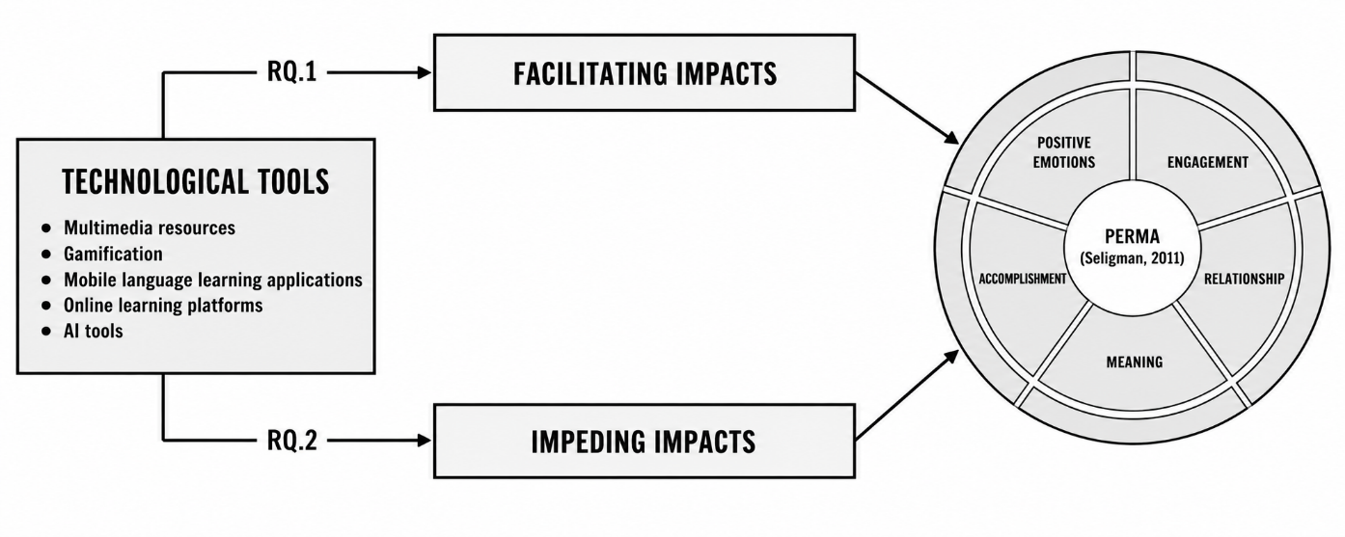
Figure 2.1. Proposed conceptual framework for the study
In summary, the theoretical review shows that technology does not exert a direct or uniform influence on learner psychology. Its effects are formed through mechanisms such as the stakes of practice, the speed and quality of feedback, autonomy, authenticity, social presence, and the visibility of progress. This provides the basis for moving to the participants’ specific stories, in which these mechanisms appear, combine, or fail in their learning lives.
CHAPTER 3: METHODOLOGY
3.1. Research paradigm and qualitative design
The study is situated within a constructivist-interpretivist paradigm. Ontologically, learners’ psychological experiences are not treated as a single reality separable from context, but as multiple realities shaped by each learner’s history, goals, competence, relationships, and technology use. One tool may be experienced by one learner as a source of freedom and by another as a source of pressure. Epistemologically, knowledge of these experiences is co-constructed through participants’ stories, the researcher’s prompts, and the interpretive process.
A qualitative design was selected because the study seeks to understand processes and mechanisms rather than estimate frequencies in a large population. Experiences such as confidence, belonging, meaning, or accomplishment cannot be fully understood through scale scores alone. Narrative data allow learners to situate events over time, explain why an experience was memorable, and describe transitions from anxiety to confidence or from interest to dependence.
3.2. Narrative inquiry
Narrative inquiry regards stories both as data and as a means through which people organise and make sense of experience. Stories are particularly valuable in second language education because learning unfolds over time and is tied to changing identities, emotions, relationships, and opportunities for participation. A learner does not merely report “I like this application”, but may narrate a sequence: initially fearing listening, then finding subtitled videos, replaying them repeatedly, recognising improved comprehension, and eventually daring to communicate with others. Such a sequence reveals a mechanism and developmental trajectory that a cross-sectional survey is unlikely to capture.
The dissertation adopts an analysis-of-narratives approach. Each story was first read holistically to preserve context and individual voice, then coded and compared across cases to identify shared patterns. This approach balances individual depth with cross-case thematic development. Negative or deviant cases—where a tool failed to produce the expected effect or where learners reported contradictory experiences—were retained to refine interpretation.
3.3. Researcher positionality and reflexivity
The researcher was also a lecturer at the research site, which provided contextual understanding of the curriculum and institutional culture but also introduced possible bias and power asymmetry. Participants might have attempted to provide favourable responses or responses they believed aligned with a lecturer’s expectations. To mitigate this risk, data collection took place after the course had ended and grades had been released; participation was entirely voluntary; pseudonyms replaced identities; and students were explicitly assured that their responses would not affect academic results.
Reflexivity was maintained throughout by recording assumptions, considering how prompts might shape stories, checking interpretations against original data, and discussing analytic decisions with supervisors. The researcher did not claim absolute neutrality, but made his position explicit and managed its influence systematically. Follow-up interviews and member checking enabled participants to confirm, correct, or elaborate the researcher’s interpretations. This approach reflects the view that narrative knowledge is co-constructed while still requiring transparency and scholarly trustworthiness.
3.4. Advantages and challenges of narrative inquiry
A major advantage is its capacity to capture the temporality, context, and contradictions of experience. Stories are nevertheless selective, dependent on memory, and shaped by an anticipated audience. Narrative frames may also restrict what participants recount if prompts are too prescriptive. The study mitigated these limitations through a bilingual version, open spaces, a free-writing section, pre-writing guidance, and clarifying interviews. Findings are interpreted as contextually situated understandings rather than universal truths.
3.5. Research setting and participants
The study was conducted at a private university in Vietnam, where English is a compulsory general-education subject for non-major students. The setting was appropriate because learners came from different disciplines, carried demanding disciplinary workloads, and varied in their investment in English. Technology use increased substantially during online teaching and continued afterwards, creating a blended ecology of official institutional platforms and tools independently selected by students.
Fifteen participants were purposively recruited to maximise variation in gender, year of study, disciplinary major, home province, and English-learning experience. They studied Traditional Medicine, Pharmacy, Law, Economic Law, and Business Administration. A sample of 10 to 15 participants is appropriate for narrative inquiry because it provides diversity for comparison while preserving the possibility of in-depth case analysis. The pseudonyms Khang, Minh Anh, Phong, Chung, Tùng, Linh, Minh, Diệp, Bích, Phương Anh, Chuyên, Quân, Diệu Ly, Ngọc Anh, and Ngọc Hân were used to protect identity.
3.6. Data-collection instrument: narrative frames
A narrative frame is a story template containing prompts and spaces that participants complete with their own experiences. It offers a common structure that keeps data directly relevant to the research questions while still enabling learners to select events, details, and interpretations. The frame contained sections on background information and technology-use history; experiences of Positive emotions; engagement; relationships; meaning; accomplishment; barriers; and a free-response section for experiences not covered by the prompts.
The prompts did not require participants to use PERMA terminology. Instead of asking directly “How did this tool affect Meaning?”, the frame invited them to describe occasions when English became useful, connected to personal goals, or helped them imagine their future. This phrasing reduced theoretical burden and encouraged experience-near language. The bilingual English-Vietnamese version enabled fuller expression and prevented English proficiency from becoming a barrier to data quality.
The instrument was developed through a literature review, expert consultation, and piloting. Six students participated in the pilot to assess prompt clarity, sequencing, and completion time. Their feedback was used to remove repetitive questions, refine wording, and add writing space. Main-study participants received study information and sufficient time to consider participation before providing consent.
3.7. Data-collection procedures
The narrative-writing session was held in a quiet venue near the university, where participants could sit apart and concentrate. Before writing, the researcher explained the nature of narrative accounts, emphasised that there were no right or wrong answers, encouraged both positive and negative experiences, and assured confidentiality. Participants were given sufficient time to recall events, describe them, and add details.
After collecting the narrative frames, the researcher reviewed omissions, ambiguities, and analytically promising passages lacking contextual detail. A group of participants was invited to semi-structured follow-up interviews to clarify meanings, confirm event sequences, and elaborate important points. The interviews were not treated as a separate primary dataset, but as a supplementary procedure for member checking and strengthening interpretive credibility.
3.8. Research ethics
The study received institutional approval and permission. Participants were given information sheets, signed voluntary consent forms, retained the right to withdraw, and were assured that participation would not affect their studies. Data were securely stored, and real names and identifying information were excluded from reporting. When Vietnamese data were translated into English for presentation in the dissertation, translations were checked to preserve meaning and nuance.
3.9. Data analysis through hybrid coding
The data were analysed through Braun and Clarke’s (2006) six phases, combining inductive and deductive coding. The first phase involved familiarisation. The researcher repeatedly read all stories, noting technology-use contexts, emotional tone, event sequences, and turning points. Holistic reading before segmenting codes helped preserve narrative coherence and reduced the risk of searching only for PERMA-compatible keywords.
The second phase generated initial codes. A coding unit could be a word, phrase, sentence, or brief event. Codes remained close to participants’ meanings while also reflecting the function of the tool, for example, “short task lowers pressure”, “subtitles allow control of input”, “notifications interrupt the flow of attention”, “AI provides an example for independent rewriting”, or “wholesale translation removes effort”. A passage could receive multiple codes when it simultaneously expressed emotion, engagement, and accomplishment.
The third phase involved searching for themes. Related codes were grouped into broader patterns, such as enjoyment through multimedia and gamification; confidence through private rehearsal; relationships through feedback and collaboration; meaning through authentic input; or accomplishment through visible progress. At this stage, PERMA served as a deductive lens for organising patterns, while new codes such as distraction, assessment opacity, time poverty, and AI dependence were developed inductively from the data.
The fourth phase reviewed themes at two levels: coherence among excerpts within each theme and the capacity of the thematic structure to represent the dataset as a whole. Overly broad themes were separated, and overlapping themes were distinguished using conceptual criteria. For example, “enjoying a video” was analysed as a momentary positive emotion, whereas “repeatedly returning, maintaining interest, and investing time” was analysed as affective engagement. Cases that did not fit the dominant pattern were used to test interpretive boundaries.
The fifth phase defined and named themes. Each theme was described in terms of its core meaning, mechanism, and scope. Rather than merely stating “technology increases Positive emotions”, the naming and interpretation identified how technology did so through low-stakes practice, immediate feedback, autonomy, authentic content, or visible progress. Mechanism-oriented naming strengthened the explanatory value of the findings.
The sixth phase involved interpretation and reporting. Themes were compared across the 15 cases, related to the literature, and organised into two findings chapters: facilitative and impeditive influences. The analysis did not stop at frequency; richness, typicality, contrasting cases, and the location of events within learners’ trajectories were also considered.
3.10. Trustworthiness and dependability
Credibility was strengthened through thick contextual description, an audit trail linking excerpts to codes and themes, member checking, supervisory discussion, and illustrative evidence. Transferability was supported by describing participants and technological ecologies so that readers could judge relevance to other contexts. Dependability was addressed through a consistent analytic process and retention of coding decisions. Confirmability was reinforced through reflexivity, attention to negative cases, and clear separation of data from interpretation.
Hybrid coding constitutes an important methodological contribution. Deduction alone risks forcing the data into PERMA, whereas induction alone may diffuse the focus and weaken theoretical connection. The two-way process allowed PERMA to guide without constraining the data. Consequently, complex experiences—such as short-term enjoyment accompanied by superficial learning, or AI convenience accompanied by diminished confidence—were preserved rather than reduced to simply positive or negative categories.
CHAPTER 4: FACILITATIVE INFLUENCES OF TECHNOLOGICAL TOOLS ON LEARNERS’ PERMA
4.1. Participants’ technological tool-use ecologies
The data show that the 15 students did not depend on a single tool. They constructed personal learning ecologies by combining class platforms, video and audio resources, gamified applications, dictionaries, translation tools, AI, collaborative documents, and online communities. All 15 participants used multimedia resources and AI tools or AI-enabled features. Fourteen used gamified tools; 14 used online learning platforms, collaborative tools, or communities; and 13 used dictionary, pronunciation, or mobile-learning applications.
YouTube was particularly prominent, alongside TikTok, podcasts, Spotify, TED Talks, cartoons, and listening channels. Zoom, Teams, Google Meet, Google Classroom, and learning management systems were used for classes, assignment submission, and feedback. Google Docs, Padlet, Zalo, Facebook, and Discord extended collaboration beyond the classroom. Duolingo, Quizlet, Memrise, Anki, Cake, and ELSA Speak supported short practice, vocabulary, and pronunciation. ChatGPT, Gemini, Grammarly, and Google Translate were used for explanation, checking, suggestions, and rehearsal.
Each ecology reflected different goals, weaknesses, access conditions, and preferences. Khang combined music, games, international communities, pronunciation tools, and AI. Some participants relied primarily on dictionaries and translation to complete tasks, whereas others prioritised video, gamified applications, or communication groups. The meaningful unit of analysis was therefore not the application itself, but the way tools were combined within a particular activity.
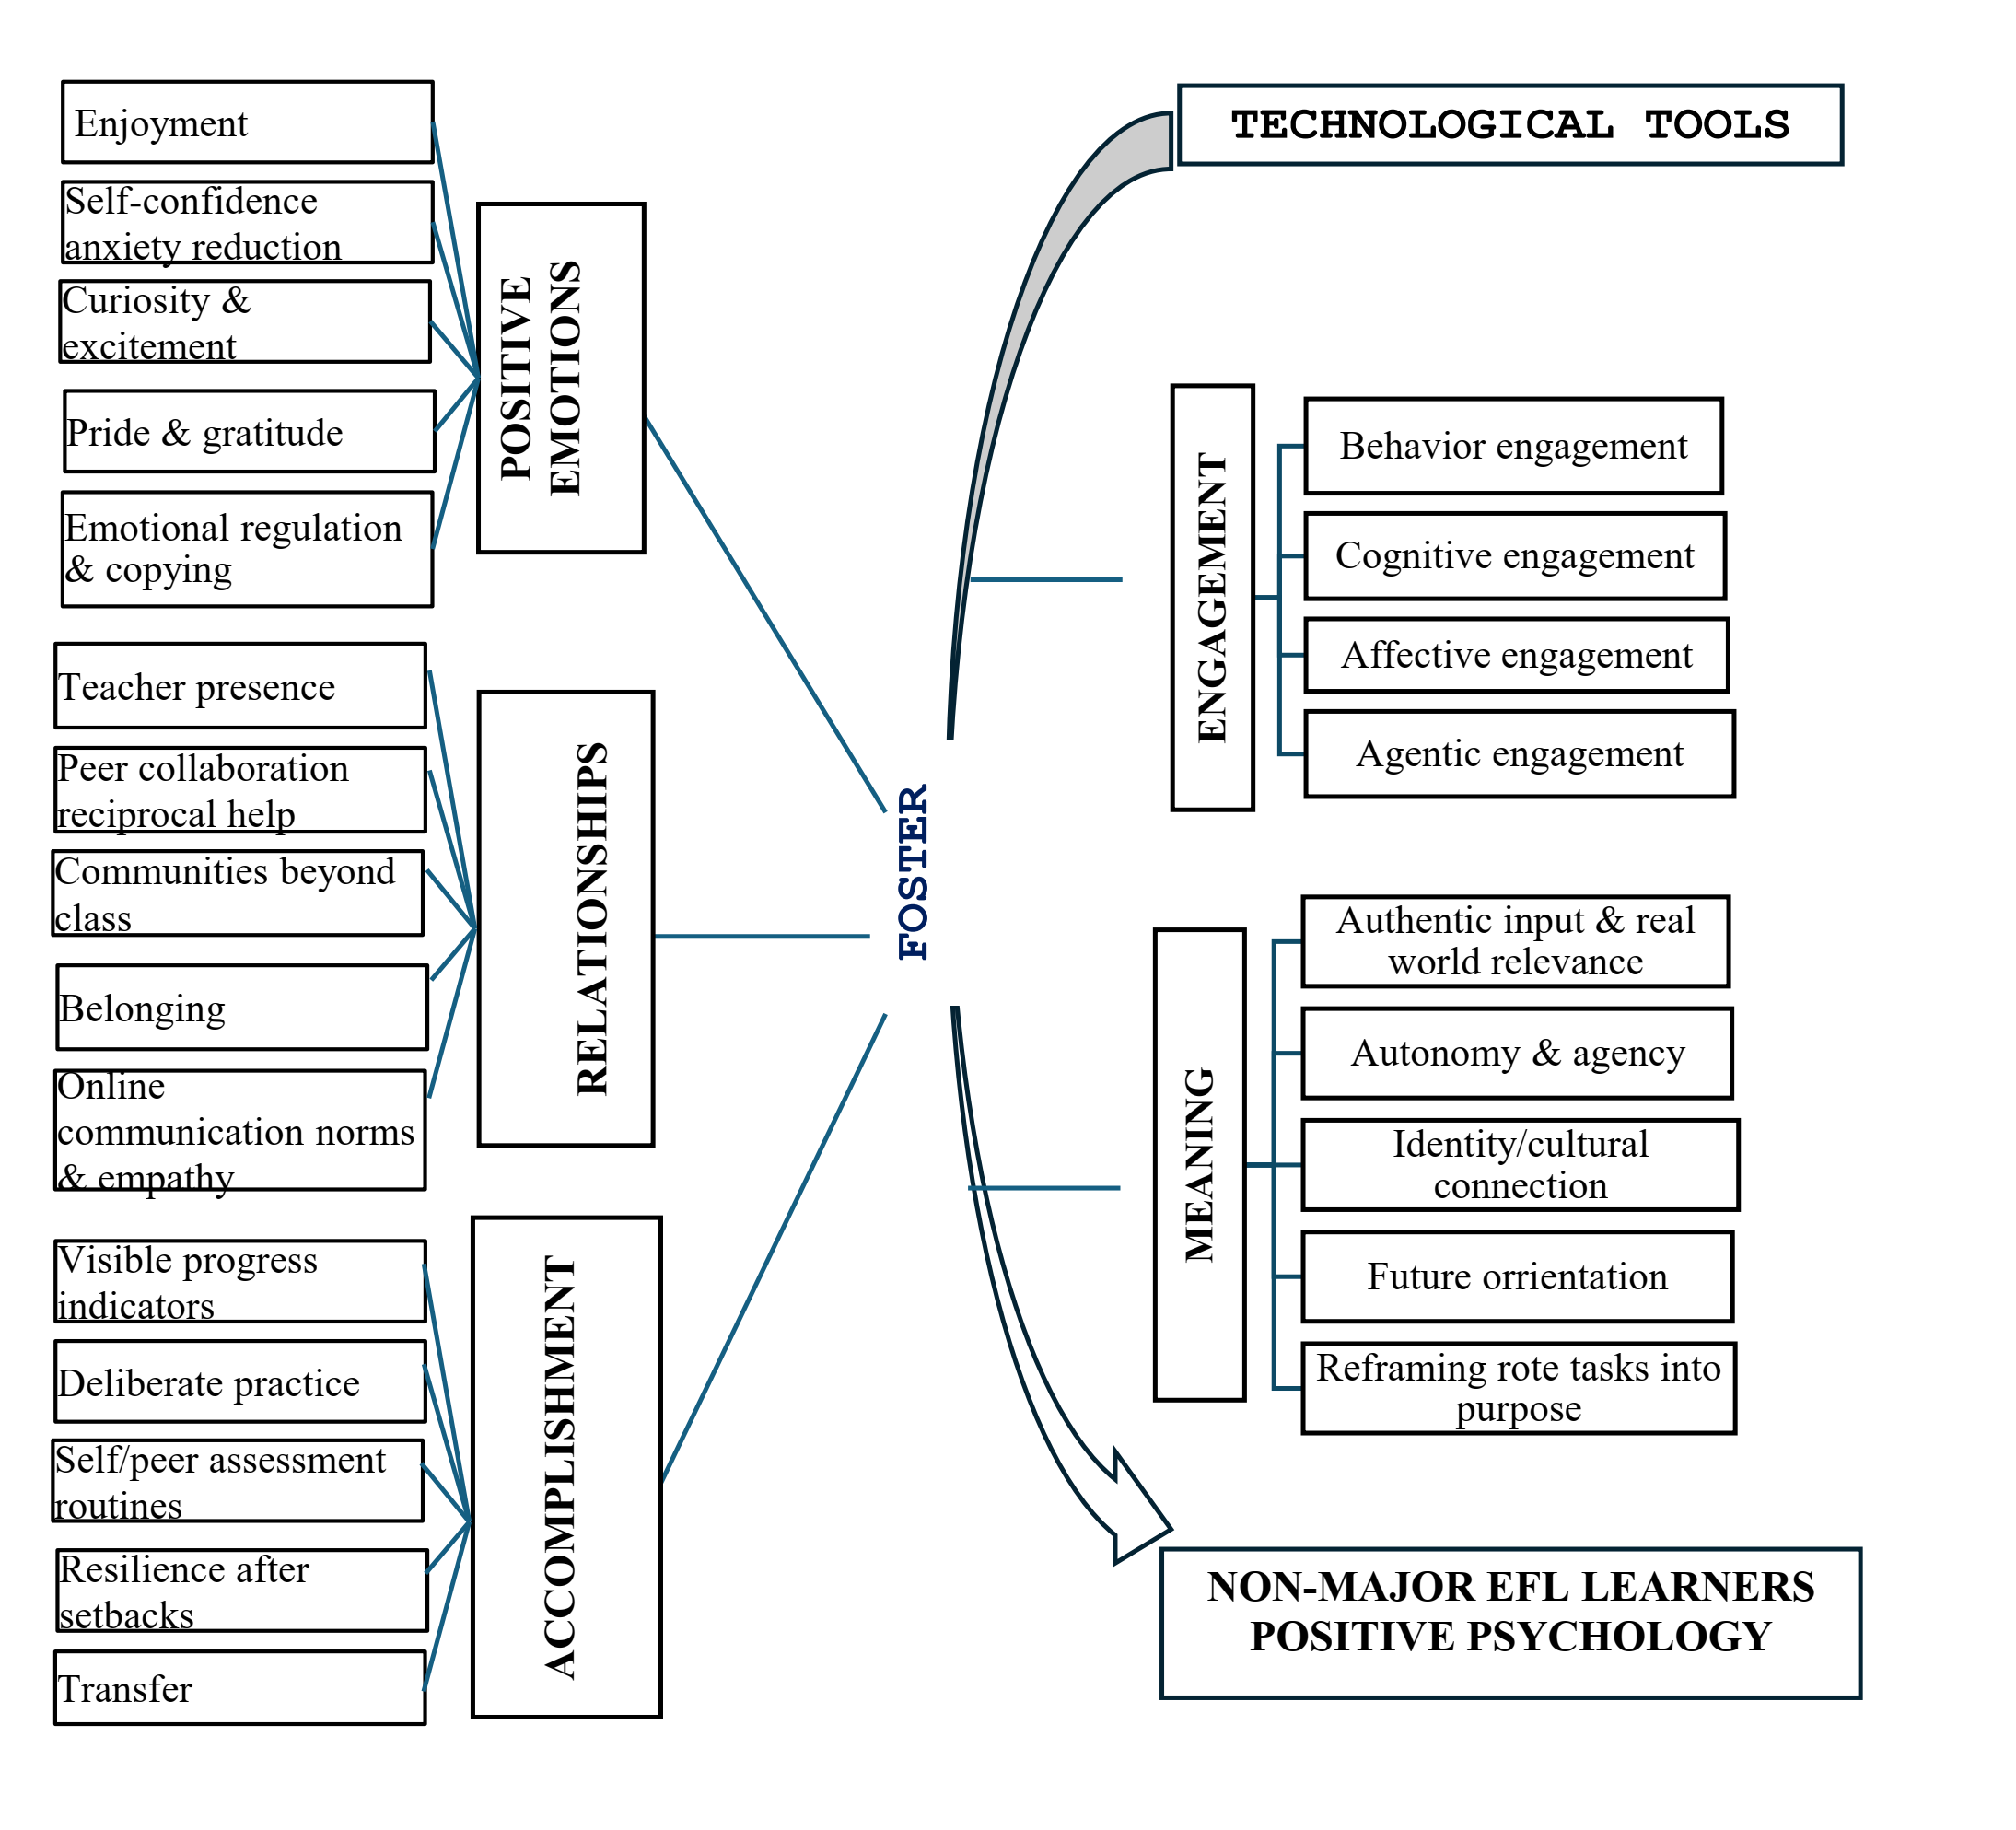
Figure 4.1. Key facilitative influences of technological tools on PERMA
4.2. Cross-cutting mechanistic patterns
Five mechanisms recurred across the data. First, technology reduced the stakes of practice by enabling private attempts, repetition, and revision before public performance. Second, rapid feedback helped learners identify gaps and correct errors. Third, autonomy over time, content, and pace increased perceived control. Fourth, authentic input and real communities connected English with everyday life, culture, and careers. Fifth, progress signals made effort observable.
These mechanisms commonly generated sequences of effects rather than isolated outcomes. For example, a video aligned with personal interests produced immediate enjoyment; replay supported sustained attention; comprehension increased confidence; authentic content created meaning; and recognising improved listening generated accomplishment. Similarly, AI feedback could reduce anxiety, but its longer-term value emerged only when learners used it to revise and reconstruct language themselves.
4.3. Positive emotions cultivated through technology
Positive emotions constituted one of the clearest and most widespread influences. Participants described enjoyment, curiosity, excitement, relief, confidence, pride, and gratitude. These emotions did not arise simply because a tool was “fun”; they were produced by specific features that altered learners’ relationship with a task.
4.3.1. Enjoyment through multimedia, gamification, and edutainment
Videos, songs, films, podcasts, and short-form content made English less abstract. Images, sound, stories, and preferred topics created a sense of exploration rather than compulsory exercise completion. The ability to select suitable content sustained curiosity. Gamification divided large goals into small tasks and provided points, badges, and immediate feedback, thereby reducing perceived burden. Enjoyment mattered because it opened the door to approach behaviour: learners found it easier to begin and were more willing to return.
The analysis nevertheless distinguished momentary enjoyment from sustained engagement. A learner might enjoy one video without continuing to learn; enjoyment developed into affective engagement only when interest was sustained through content choice, appropriately calibrated challenge, and a sense of progress.
4.3.2. Self-confidence and anxiety reduction
Technology reduced anxiety through three mechanisms. First, learners could practise privately with pronunciation applications, model videos, or chatbots, avoiding the pressure of others’ evaluation before they felt ready. Second, they could repeat, adjust speed, and prepare in advance. Third, immediate feedback transformed errors from evidence of failure into manageable information.
Diệu Ly used AI to prepare questions and responses before an online conversation with international students. This rehearsal did not replace communication; it created a foundation from which she could enter the authentic situation with less anxiety. When the conversation continued without constant translation, the experience became evidence of competence. Similar stories show that confidence did not arise from generic encouragement, but from control over preparation and genuine experiences of success.
4.3.3. Curiosity and excitement
Content recommendations, hyperlinks, related videos, and access to topics beyond the textbook activated curiosity. Learners could pursue individual questions, discover new expressions, or explore cultural differences. Excitement generally occurred when tasks contained novelty while remaining manageable. When content was too unfamiliar or too rapid, excitement turned into overload; control of pace and semantic support were therefore important conditions.
4.3.4. Pride, gratitude, and emotion regulation
Pride emerged when learners maintained a streak, improved pronunciation, understood a listening passage, or communicated successfully. Gratitude was directed towards teachers, peers, or communities that shared resources and feedback. Technology was also used to regulate emotion: learners listened to music, viewed familiar content, shifted to smaller tasks, or used AI to clarify difficult points. These strategies helped them recover from setbacks rather than abandon the activity.
The overarching mechanism was the reduction of threat, increase in control, and production of evidence of progress. Positive emotions consequently functioned not only as outcomes but also as resources that broadened attention, increased willingness to participate, and supported resilience. The dissertation nevertheless stresses that the aim is not to eliminate all negative emotion. Moderate challenge and anxiety may signal a task’s importance; the critical issue is whether technology helps learners convert tension into controlled action.
4.4. Engagement strengthened through self-regulated technology use
The findings show that technology influenced four dimensions of engagement: behavioural, cognitive, affective, and agentic. Its strongest effects appeared when tools were connected with specific habits, strategies, and goals rather than used impulsively.
4.4.1. Behavioural engagement
Mobile applications and short tasks helped learners maintain contact with English within busy schedules. Streaks, reminders, and daily goals offered clear behavioural cues. Participants described using spare periods of 10-15 minutes to review vocabulary, listen to a short passage, or complete an exercise. Anytime access lowered initiation costs and helped transform practice into habit.
Sustainable habits, however, did not depend on reminders alone. Learners persisted more successfully when tasks were sufficiently small, feedback was meaningful, and they perceived a connection with personal goals. Dense reminders or repetitive tasks could turn the same mechanism into pressure. Behavioural engagement was therefore understood as the product of tool design and self-management working together.
4.4.2. Cognitive engagement
Dictionaries, search tools, AI, and automated feedback supported planning, hypothesis testing, comparison of expressions, and self-correction. Learners could request explanations, locate examples, listen to multiple pronunciation models, and compare drafts. Cognitive value emerged when a tool prompted deep processing: learners read feedback, identified the source of an error, rewrote, and tested language in a new context.
Some participants constructed tool chains: watching a video for input, consulting a dictionary for meaning, asking AI about a structure, and then independently writing or recording. Such chains reflected cognitive engagement because learners actively coordinated resources, monitored understanding, and adapted strategies. Technology functioned as a scaffolding system rather than a source of answers.
4.4.3. Affective engagement
Affective engagement was evident in sustained interest, absorption, and a desire to continue. It differed from momentary enjoyment in both duration and investment. Interactive activities, interest-aligned content, and manageable challenge created deep concentration or flow-like states. When learners lost track of time, continued exploring after a compulsory task ended, and voluntarily returned, the data were interpreted as affective engagement.
4.4.4. Agentic engagement
Learners did not merely respond to tools; they shaped their learning environments. They disabled notifications, adjusted speed, selected suitable applications, asked teachers for explanations, located communities, formed groups, and proposed working methods. Ngọc Anh showed how turning off notifications and organising her learning space protected concentration. These actions demonstrated agency: learners changed conditions in order to learn more effectively.
Collaboration could also be agentic when students contributed resources, gave peer feedback, and co-designed products. Engagement was therefore not simply “being present” or “completing” work, but intentional investment in constructing the learning experience.
4.4.5. Mechanisms of engagement
Three mechanisms were particularly prominent: lowering initiation costs, maintaining feedback loops, and increasing control. Small tasks facilitated starting; feedback made outcomes visible; and choice and personalisation supported continuation. When these mechanisms operated together with appropriate challenge, technology fostered both persistence and deep processing. If a tool offered only rewards or surface interaction, engagement could remain behavioural without developing cognitively or affectively.
4.5. Relationships expanded and supported
Relationships in the data were not confined to the classroom. Technology connected learners with teachers, classmates, learners elsewhere, and English-using communities. Relational value emerged through presence, feedback, reciprocal support, belonging, and communication norms.
4.5.1. Teacher presence
In digital environments, teachers were perceived as “present” when they responded promptly, provided clear guidance, recognised difficulties, and created opportunities for interaction. Messages, comments on assignments, online consultation, and audio feedback extended support beyond class time. When learners knew that questions would be answered and errors addressed without judgement, they became more willing to participate.
Presence did not mean that a teacher had to be continuously visible on screen. Responsiveness and the quality of guidance were more important. Specific feedback identifying strengths, errors, and the next corrective step simultaneously supported relationships, cognitive engagement, and accomplishment. Feedback thus operated at the intersection of R, E, and A.
4.5.2. Collaboration and reciprocal support
Google Docs, Zalo groups, Padlet, and sharing platforms enabled students to co-write, comment, distribute responsibilities, and retain revision histories. Collaboration reduced the feeling that each learner had to solve every difficulty alone and transformed peers into resources for one another. Explaining a point to a peer also consolidated the helper’s knowledge. Relationships were reciprocal rather than limited to receiving assistance.
The narratives showed that group work was effective when responsibilities were clear, the shared product was meaningful, and feedback was sufficiently specific. If members remained silent or offered only generic comments, the tool itself did not create community. Task structure and collaborative norms were therefore mediating conditions.
4.5.3. Communities beyond the classroom
Discord, HelloTalk, Facebook, Reddit, Telegram, English clubs, and gaming communities opened interaction with real users. Learners encountered diverse ways of speaking, naturally occurring topics, and genuine communicative needs. Out-of-class relationships made English less closely associated with assessment and more clearly a means of participation. For some participants, receiving a response from an international member or being understood produced a sense of recognition as an English user.
4.5.4. Belonging
Belonging developed when learners felt that they had a place, a voice, and acceptance. Online learning groups sustained contact during social distancing and provided spaces for sharing difficulties. Small successes acknowledged by peers strengthened confidence and motivation. Belonging also lowered the emotional risk of speaking inaccurately.
4.5.5. Communication norms and empathy
Digital communication required norms concerning response time, feedback language, and respect for difference. Learners developed ways of expressing criticism politely, explaining clearly, and considering others’ feelings. The absence of non-verbal cues could cause misunderstanding, but reflection on how messages and feedback were worded also fostered digital empathy.
Overall, technology supported Relationships not because it provided technical “connectivity”, but because it created opportunities for responsiveness, reciprocity, and recognition. Where interaction remained procedural, relationships remained thin. Where presence, shared purposes, and high-quality feedback were established, relationships became resources sustaining Positive emotions, engagement, and resilience.
4.6. Meaning strengthened through authenticity, autonomy, and future orientation
Meaning emerged when learners saw worthwhile reasons for learning English and connected present activities with themselves, their communities, or their futures. Technology strengthened meaning by expanding content, interlocutors, and products beyond the textbook.
4.6.1. Authentic input and real-world relevance
Videos, podcasts, news, forums, and discipline-specific content showed learners how English was used to address real needs. Medical and Pharmacy students could access professional materials; Law and Business Administration students could observe workplace situations. When learners understood a video or text that they had previously considered too difficult, they recognised the direct value of language competence.
Authenticity resided not only in source materials but also in tasks. Writing an email, preparing a presentation, interacting with international users, or producing a public artefact gave language a recipient and a purpose. Such tasks shifted the focus from “being correct to obtain a mark” to “communicating to achieve an outcome”.
4.6.2. Autonomy and agency
The ability to select content, timing, and tools enabled learners to construct appropriate learning pathways. Autonomy generated meaning when choices were connected to personal goals rather than constituting unguided freedom. A student might select videos in a disciplinary field, use pronunciation software to prepare for an interview, or join an interest-based community. When learners saw their decisions shaping outcomes, they experienced ownership of learning.
4.6.3. Identity and cultural connection
Exposure to diverse speakers and content enabled learners to imagine themselves as potential members of English-using communities. They did not need to conform to an idealised “native speaker” model, but could develop identities as English users for learning, work, and connection. Videos and online interaction also increased awareness of cultural differences, politeness practices, and language varieties.
4.6.4. Future orientation
Technology helped learners connect present tasks with careers, postgraduate study, travel, or international communication. Small successful experiences—understanding a disciplinary text, writing a better email, or conversing without translation—made future possibilities more credible. Meaning was therefore not an abstract claim that “English is important”, but a concrete image of where, how, and for whom competence would be used.
4.6.5. Reframing rote tasks as purposeful practice
Some activities formerly perceived as repetitive became meaningful when technology placed them in context. Learning vocabulary through video, examples, sound, and spaced review connected words with use; pronunciation practice with authentic models made differences audible; and rewriting after feedback clarified why correction was necessary. The core mechanism was making the relationship between an operation and its goal explicit.
Meaning had a protective role when learners encountered difficulty. Enjoyment could decline, but when a task connected with a career goal or desired identity, learners continued. The findings show that Meaning was both produced by technology and a factor shaping learners’ selection and persistence with technology. Learners with clear goals tended to use tools more selectively and were less easily drawn into surface interaction.
4.7. Accomplishment through progress, practice, and transfer
Accomplishment was expressed through perceived progress, goal attainment, skill mastery, and transfer to new situations. Technology made incremental gains visible, but sustainable accomplishment required evidence of competence rather than activity metrics alone.
4.7.1. Visible progress indicators
Scores, levels, streaks, charts, and work histories provided feedback on trajectories. Learners could compare pronunciation, written products, or results before and after practice. When indicators were clear and valid, they generated a sense of competence and reinforced the belief that effort produced change. Small goals also made large tasks less overwhelming.
The data nevertheless show that indicators were valuable only when learners understood what they represented. A streak indicated presence; a multiple-choice score could reflect recognition rather than use. Deeper accomplishment emerged when digital signals were combined with products, qualitative feedback, and performance in different situations.
4.7.2. Deliberate practice with specialised tools
ELSA Speak, YouGlish, audio dictionaries, flashcard systems, and adaptive exercises supported practice focused on particular weaknesses. Learners could receive a model, attempt a task, compare performance, and repeat. This loop approximated deliberate practice through a specific goal, immediate feedback, and adjustment. When learners selected a sound, structure, or lexical set to improve, technology concentrated resources on that need.
4.7.3. Self-assessment and peer assessment
Version-tracking tools enabled learners to see the revision process. Peer feedback on shared documents provided opportunities to apply criteria and learn from others’ products. Recording, replaying, and comparing speech with a model developed monitoring capacity. These activities transformed assessment from an end-point event into a continuing process.
4.7.4. Resilience and recovery from setbacks
Accomplishment did not consist only of uninterrupted success. Several stories described low scores, failed listening comprehension, or extensive correction, followed by using tools to analyse errors and try again. The possibility of repetition in a private environment reduced the cost of failure. When improvement after multiple attempts became visible, learners developed a belief that competence was malleable.
4.7.5. Transfer to academic and professional contexts
The strongest accomplishment was reported when skills transferred to authentic tasks: presentations, reading disciplinary materials, writing emails, interviews, or communication with people from other countries. Transfer confirmed that progress was not confined to an application. It also strengthened Meaning by showing that competence served wider purposes.
4.8. Interactions among the PERMA elements
The elements rarely appeared separately. An experience might begin with enjoyment, develop into concentration, lead to collaboration, create a sense of purpose, and end in pride. Relationships were often spiral-like: accomplishment increased confidence; confidence promoted participation; participation extended relationships; relationships supplied feedback and new opportunities; and these opportunities generated further meaning and accomplishment.
The findings also show that a strong element could temporarily compensate for a weak one. Professional meaning could sustain engagement when an activity was not enjoyable; supportive relationships could help learners overcome breakdowns; and small progress could restore emotion. Compensation nevertheless had limits. If infrastructure repeatedly failed or assessment was unfair, trust and accomplishment weakened despite learner motivation.
The central contribution of Chapter 4 is the movement from describing that “technology creates interest” to explaining mechanisms. Technology fostered PERMA when it reduced risk, supplied actionable feedback, enabled private rehearsal, increased autonomy, introduced authentic content, supported responsive relationships, and made progress visible. The effect did not reside within the tool, but in the fit among tool affordances, tasks, and learner action.
CHAPTER 5: IMPEDITIVE INFLUENCES OF TECHNOLOGICAL TOOLS ON LEARNERS’ PERMA
5.1. Technical and infrastructural breakdowns
Connection failures, weak devices, software errors, data loss, and malfunctioning microphones or cameras were the most immediate barriers. Initial effects typically appeared in P and E: anxiety, frustration, fear of losing information, and disrupted concentration. Effects then spread to R when learners could neither hear nor be heard or missed messages; to M when the promised flexibility of technology was replaced by compensatory work; and to A when submissions, scores, or assessments reflected technical conditions rather than competence.
Ngọc Hân recounted a test failure caused by technical problems, which distorted her sense of accomplishment. Ngọc Anh experienced Zoom audio problems and was not fully assessed; Tùng lost data. These cases show that breakdowns were more than inconveniences. They disrupted the relationship between effort and outcome, thereby weakening trust in the system and willingness to invest further effort.
5.2. Attention fragmentation and digital distraction
The devices used for learning also contained social media, messaging, games, and entertainment. Notifications, application switching, and competing tabs reduced sustained concentration. The primary locus of impact was Engagement, but effects spilled over to Accomplishment through superficial processing and delayed completion; to Meaning when learning became a sequence of purposeless actions; and to Positive emotions through frustration, guilt, or loss of control.
Learners developed strategies such as disabling notifications, activating cameras, taking notes, setting time limits, and using focus modes. These strategies confirm that engagement in digital environments is an achievement of self-regulation rather than an automatic result of interactivity. When tool design continually competes for attention, the regulatory burden is transferred to the learner.
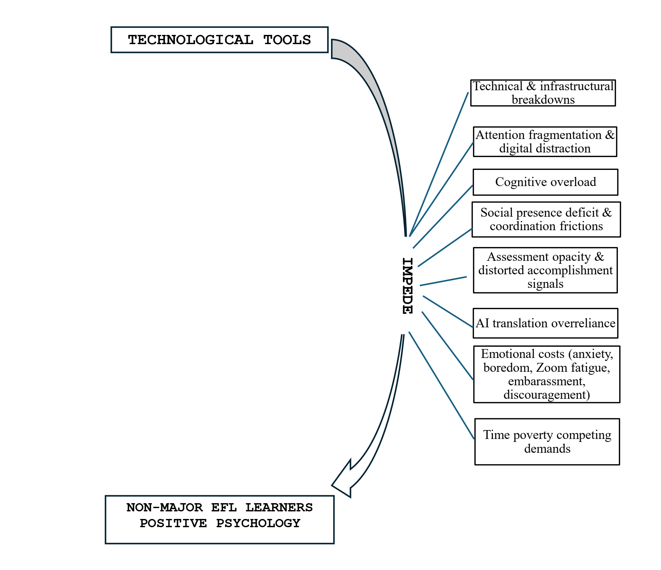
Figure 5.1. Key impeditive influences of technological tools on PERMA
5.3. The cascading nature of barriers
Barriers had a “primary locus” but generally produced spillover effects. Distraction primarily weakened E; social presence deficits strongly affected R and P; assessment opacity directly affected A; and AI overreliance reduced cognitive E, M, and A. Mapping barriers onto PERMA avoids treating them as isolated technical problems and reveals their psychological and pedagogical costs.
An important point is that benefits and barriers may arise from the same tool. Reminders support habits but can also create pressure; automated feedback clarifies errors but may be trusted excessively; online classes maintain access but reduce social cues; and AI lowers anxiety but may replace thinking. Evaluating technology therefore requires attention to thresholds, intensity, and patterns of use.
5.4. Design and pedagogical constraints and cognitive overload
Participants described text-heavy slides, excessively rapid videos, simultaneous use of multiple platforms, ambiguous instructions, and tasks misaligned with proficiency. When information exceeded processing capacity, learners lost the main point, became less confident, and adopted coping strategies such as copying or skipping. Overload directly affected cognitive E, but also reduced P through anxiety and disappointment, weakened M when activities no longer had clear relevance, and diminished A because outcomes did not represent understanding.
Ngọc Anh reported difficulty with listening speed when it could not be controlled. When a tool allowed speed adjustment, replay, and selective subtitles, it provided scaffolding; without these features, authentic input became a barrier. This case illustrates the principle that authenticity must be accompanied by control and support. Similarly, surface interaction such as clicking many buttons did not guarantee deep processing. A tool could be “interactive” at the interface level while remaining cognitively impoverished.
Pedagogical misalignment also occurred when new tools were adopted without redesigning tasks. Transferring a long lecture to Zoom or uploading text-heavy material to an LMS merely digitised the form and did not create a better learning experience. Technology needed to be integrated with clear goals, criteria, and feedback; otherwise, learners spent resources understanding procedures rather than learning language.
5.5. Social presence deficit and coordination friction
In some online classes, learners felt silent, invisible, or uncertain whether others could hear them. Delay, switched-off cameras, slow responses, and absent non-verbal cues reduced interpersonal closeness. The primary impact was on Relationships, but Positive emotions and willingness to communicate also declined. When learners spoke without receiving a response, they could interpret silence as rejection or negative evaluation.
Minh Anh recounted an earlier experience of contributing in an online class and receiving no response; the silence was experienced as public rejection and continued to influence whether she spoke in later classes. This case shows that relational experiences can leave long-term traces. Limited presence is not merely “less interaction”; it can shape expectations and avoidance behaviour.
Coordination friction arose when groups struggled to agree on schedules, responsibilities were unclear, members responded slowly, or document versions conflicted. Collaborative tools did not remove the need for leadership and norms. When responsibility was not structured, some students carried most of the workload, producing unfairness and tension. This weakened R, reduced the E of active members, and meant that the A represented by a group product did not reflect individual contributions.
The solution was not simply to increase the number of meetings. High-quality presence needed to be designed through brief check-ins, acknowledgement responses, small-group opportunities, turn-taking rules, feedback criteria, and transparent task allocation. Teachers served as social anchors, helping learners know that they were seen and that their work had an audience.
5.6. Task-tool misalignment
Some tools suited recognition practice but were used to assess production; some gamified activities prioritised speed when the objective required reasoning; and some AI systems supplied texts that were too polished for learners’ proficiency. When tools and goals were misaligned, learners could obtain digital results without developing the intended competence. This weakened Meaning because the purpose of the action was unclear and Accomplishment because the success signal was unreliable.
5.7. Assessment opacity and distorted accomplishment signals
Assessment opacity refers to uncertainty about criteria, system scoring, the meaning of feedback, or reasons for score changes. In digital environments, learners often received multiple signals—scores, colours, automated comments, and peer feedback—but not every signal diagnosed a problem. When learners did not know what to change, feedback did not become learning.
Chuyên wanted peer feedback that identified particular sentences and words rather than general comments such as “unclear”. Ambiguous feedback forced learners to guess, reducing cognitive engagement and trust in collaborative relationships. Opacity also arose when technical errors deleted work, systems recorded activity incorrectly, or scores depended on connection speed. In such situations, Accomplishment became disconnected from competence, leading to anxiety, reduced meaning, and diminished effort.
Distorted accomplishment signals could also be falsely positive. Completing many easy exercises, maintaining a streak, or receiving a high tool-generated score did not necessarily indicate the ability to use language. If learners confused activity with progress, they could postpone more difficult tasks. Digital assessment therefore needed to be transparent, draw on multiple sources, and connect with authentic products.
5.8. AI/translation overreliance and superficial learning
The data distinguished four modes of AI-mediated activity. First, AI functioned as scaffolding when it provided hints, explanations, examples, error diagnoses, or alternative wording while learners continued to understand, select, and reconstruct language. Second, AI served as a rehearsal partner when learners tested questions, conversations, or drafts before undertaking authentic tasks. These two modes could reduce anxiety, increase engagement, and support accomplishment.
Third, “outsourcing cognition” occurred when learners delegated a central operation—such as generating ideas, organising an argument, or constructing sentences—to the tool and made only surface edits. Fourth, “bypassing learning” occurred when translation or AI was used to complete a product with almost no processing of its content. In these latter modes, tasks were completed while learning activity was shortened or removed.
Phong described occasions when he could no longer remember which sentences he had written and which ChatGPT had suggested; he had to rewrite without the tool to test his remaining competence. This experience revealed erosion of ownership and confidence. Ngọc Anh likewise used AI to understand difficult passages and check wording, but deliberately avoided allowing it to replace her thinking. Khang warned that a long translated sentence could be contextually inaccurate if the learner did not analyse it.
The PERMA effects of AI dependence were paradoxical. It provided immediate relief in P and rapid surface completion in A, but could undermine cognitive E, the Meaning of a task, and genuine Accomplishment. Over time, learners might trust their own ability less and become more anxious when the tool was unavailable. The distinguishing criterion was therefore not the name of the application, but the cognitive work remaining with the learner before, during, and after AI output.
A responsible-use sequence involves attempting independently first; asking specific questions; checking sources and contextual appropriateness; explaining why suggestions are accepted or rejected; rewriting in one’s own language; and transferring learning to a new task. Teachers need to design tasks that require process evidence, reflection, and explanation of decisions rather than assessing only the final product.
5.9. Emotional costs
Technology created emotionally ambivalent experiences. Alongside enjoyment and confidence, learners described anxiety, boredom, screen fatigue, embarrassment, and discouragement. These emotions were not merely short-term moods; they could become a “psychological tax” that reduced willingness to participate and narrowed cognitive resources.
Anxiety occurred when speech was too rapid, presentations had to be made on camera, learners were unsure whether the system had recorded their work, or feedback was delayed. Minh Anh had previously feared listening because she lost the thread within the first few seconds; repeated failure produced an enduring cycle of fear and avoidance. Boredom and fatigue arose in lengthy, low-interaction classes, monotonous content, or prolonged screen use. Embarrassment increased when errors occurred publicly or were preserved in recordings. Discouragement emerged when effort did not produce visible results.
Emotional costs primarily affected P but quickly spread to E, R, and A. Anxiety led learners to avoid speaking; boredom reduced time investment; embarrassment narrowed relationships; and discouragement weakened the sense of progress. These findings indicate that the emotional quality of technology-mediated design must be evaluated, not merely its accessibility.
5.10. Time poverty and competing demands
Non-major students had to balance English with disciplinary courses, employment, family responsibilities, and rest. Technology offered flexibility but also made learning boundaries continuous. Reminders, notifications, and tasks could appear at any time, turning a personal goal into an obligation that was difficult to switch off.
Minh described overloaded weeks in which application reminders felt like surveillance. Khang disabled reminders to create rest periods but then experienced guilt. These cases show how a motivational feature can create pressure when time and energy are depleted. Time poverty reduced P, made E inconsistent, hindered the maintenance of R, weakened Meaning when learning became purely compulsory, and made A fragile as habits were interrupted.
5.11. Integrated PERMA impact map
The barriers were synthesised according to their primary loci and spillover effects. Technical breakdowns primarily disrupted engagement and emotion, then affected relationships, meaning, and accomplishment. Digital distraction primarily weakened E, but also reduced A and M. Cognitive overload affected cognitive E, P, and A. Social presence deficits directly weakened R and P while reducing participation. Assessment opacity most strongly affected A and subsequently spread to P, E, and relational trust. AI dependence weakened cognitive E, M, and genuine A. Time poverty diminished the entire system through depleted psychological resources.
These findings show that PERMA does not comprise five independent boxes. A barrier may begin in one element and cascade through others. At the same time, interventions can generate multidimensional benefits: stable infrastructure protects concentration and fairness; specific feedback supports relationships, cognition, and accomplishment; AI rules preserve ownership, meaning, and competence; and reasonable workload design protects emotion and persistence.
Chapter 5 therefore extends understanding of technology’s darker side. The issue is not simply that “difficulties exist”, but that particular mechanisms disrupt learners’ connections with tasks, other people, purposes, and evidence of competence. This perspective provides a basis for the design implications in Chapter 6.
CHAPTER 6: CONCLUSION
6.1. Overview of the major findings
The dissertation explored the experiences of 15 non-major EFL students with technological tools through the PERMA lens. In response to the first research question, the findings show that technology can foster all five elements when used within a supportive ecology. Positive emotions were generated through low-stakes practice, multimedia content, gamification, feedback, and control. Engagement was strengthened through small tasks, habits, feedback loops, deep processing, and agency. Relationships were extended through teacher presence, collaboration, reciprocity, and out-of-class communities. Meaning was reinforced by authentic input, English-user identities, and professional orientation. Accomplishment was built through progress indicators, deliberate practice, self-assessment, and transfer.
In response to the second research question, technology could also undermine PERMA. Technical failures, distraction, overload, unsuitable design, limited social presence, assessment opacity, AI dependence, emotional costs, and time poverty produced cascading effects. The barriers did not merely reduce task efficiency; they led learners to doubt their competence, experience less belonging, lose purpose, and distrust accomplishment signals.
The central finding is that effects are mechanism- and context-dependent. No tool inherently fosters or impedes PERMA. The same feature can produce opposite effects according to its use. Learning streaks sustain habits but also create pressure; AI scaffolds yet may replace thinking; authentic video creates meaning yet may overload learners; and online classes maintain connection yet can reduce presence. Analysis therefore needs to shift from “Which tool is used?” to “What cognitive, emotional, and social work remains with the learner when the tool is used?”
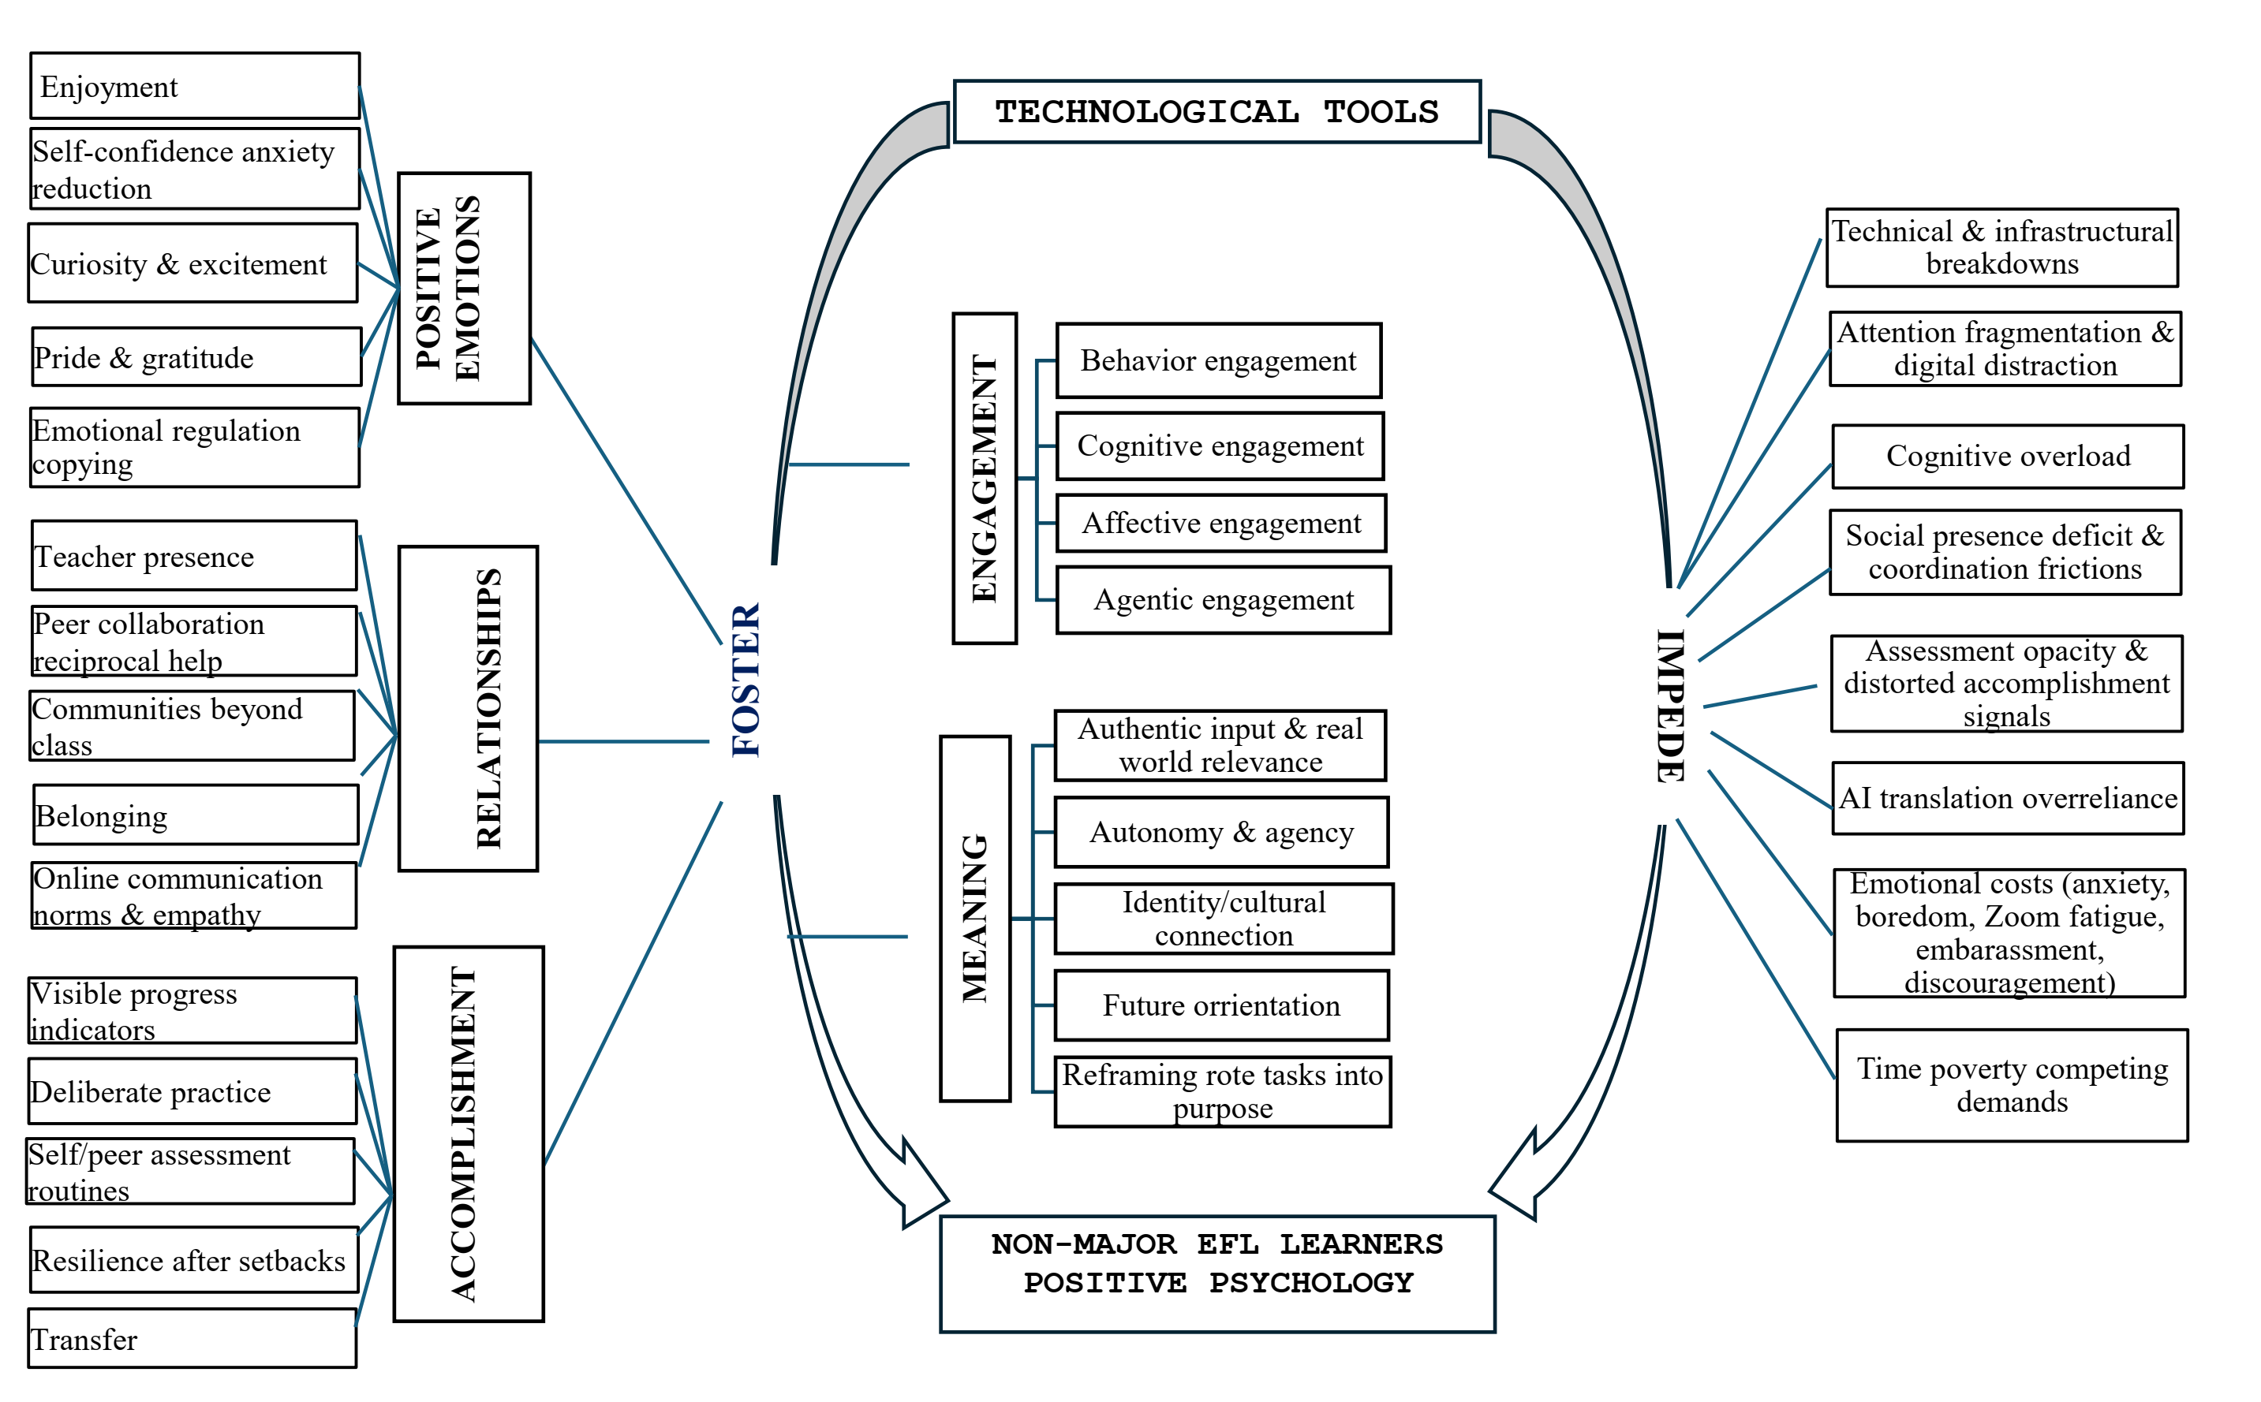
Figure 6.1. Synthesis of the major findings
6.2. Theoretical contributions
6.2.1. Contribution to positive psychology in second language acquisition
The study extends PP in SLA in three ways. First, it applies the complete PERMA model rather than concentrating only on enjoyment or anxiety, showing that foreign language learner flourishing is a system of emotion, investment, relationships, purpose, and competence. Second, it identifies mechanisms connecting technological affordances with PERMA, clarifying that Positive emotions arise not merely from “fun”, but from reduced risk, feedback, rehearsal, autonomy, and progress. Third, it emphasises ambivalence and dynamism: positive experiences can coexist with tension, and influences can change over time.
PERMA proved useful but not fully separable. Its elements formed upward or downward spirals of support and deterioration. This contribution suggests that PP research in SLA should investigate pathways and spillover effects rather than measure each variable independently. It also shifts attention from static well-being outcomes to the processes through which learners build, protect, and restore psychological resources in particular activities.
6.2.2. Contribution to technology-enhanced language learning
The dissertation proposes evaluating technology through experiential quality and the work remaining with the learner. Technology is valuable when it expands possibilities for action while keeping learners central to understanding, decision-making, production, and reflection. The distinction among AI as scaffolding, rehearsal partner, outsourced cognition, and bypassed learning offers a new analytical framework for AI use in language education.
The study also contributes the concept of personalised learning ecologies. Students did not learn with isolated applications but coordinated multiple tools according to goals and conditions. Research and design should therefore examine activity flows across tools, switching costs, feedback consistency, and the ways learners manage attention rather than evaluate a platform in isolation.
6.2.3. Contribution to narrative inquiry in EFL learner research
Narrative frames made it possible to collect data from more participants than extended autobiographies while retaining temporal structure and individual voice. Combining narrative frames, clarifying interviews, thematic analysis, and hybrid coding demonstrated a balance between narrative depth and cross-case comparison. The study also clarified the roles of co-construction, reflexivity, researcher positionality, and deviant cases.
6.3. Practical implications
For administrators and policymakers, the first priorities are stable infrastructure, technical support, and equitable access. Technology-integration policy should include criteria for digital well-being, data protection, assessment transparency, and responsible AI use. Purchasing platforms cannot substitute for pedagogical design and human capacity building.
For teacher educators, programmes need to develop technological, pedagogical, and psychological competence together. Teachers need to know how to design low-stakes practice, actionable feedback, group activities that create presence, authentic tasks, and process-oriented assessment. They also need to recognise the boundary between momentary Positive emotions and sustainable engagement, and between digital completion and genuine accomplishment.
For teachers, tool selection should begin with the intended objective and mechanism. To reduce speaking anxiety, private rehearsal can precede authentic interaction. To strengthen cognitive engagement, tasks should require explanation, comparison, revision, and transfer rather than simple selection. To develop relationships, feedback, roles, and responsiveness must be designed. Tasks should be appropriately segmented, use clear criteria, allow control of pace, and include contingency plans for technical failure.
For students, digital self-regulation is a central condition. Learners need to manage notifications, choose tools according to goals, set time limits, and examine whether an activity produces understanding or merely a feeling of busyness. When using AI, they should attempt independently first, ask specific questions, verify output, rewrite, and explain decisions. Learners also need to seek support proactively, build communities, and monitor diverse evidence of progress.
6.4. Limitations and directions for further research
The study was conducted at one institution with a small purposive sample and therefore does not seek statistical generalisation. Self-reported and retrospective data may be influenced by memory, social desirability, and lecturer-student relationships. Diverse tool ecologies mean that findings cannot be attributed to a homogeneous intervention. Technology changes rapidly, so the findings are temporally situated. Despite reflexivity and member checking, interpretation remains influenced by the researcher and the PERMA framework.
Future research could extend to multiple institutions, compare major and non-major learners, or examine groups with different technological conditions. Mixed-method and longitudinal designs could investigate changes in PERMA over time by combining digital diaries, observation, activity data, and scales. Intervention studies should test particular mechanisms, such as immediate feedback, AI rehearsal, or teacher presence. Generative AI should be studied according to the work remaining with the learner, the quality of transfer, and longer-term effects on confidence, identity, and competence.
The dissertation concludes that technology can become infrastructure for flourishing in foreign language learning when it enables learners to attempt, sustain investment, connect with others, see purpose, and build genuine competence. When stability, guidance, and cognitive ownership are absent, the same technology can produce distraction, isolation, pressure, and false accomplishment. High-quality technology integration is therefore a task of designing a psychological-pedagogical ecology, not merely selecting applications.

LIST OF PUBLISHED STUDIES
Nguyen Van Thang, & Nguyen Thi Thanh Ha (2021). The impacts of mobile-assisted language learning (MALL) on freshmen’s vocabulary acquisition and their perspectives. In V. P. H. Pham, A.-P. Lian, & A. B. Lian (Eds.), Proceedings of the 18th International Conference of the Asia Association of Computer-Assisted Language Learning (AsiaCALL–2-2021) (Vol. 621, pp. 278–290). Atlantis Press. https://doi.org/10.2991/assehr.k.211224.027
Nguyen Van Thang (2022). An overview of positive psychology in second language acquisition. In Proceedings of the 2022 International Graduate Research Symposium (pp. 947–957). University of Languages and International Studies, VNU: Vietnam National University Press, Hanoi. ISBN 9786043848311
Nguyen Van Thang (2023). Students’ perceptions on positive psychology in English learning at Thanh Dong University. VNU Journal of Foreign Studies, 39(6), 100–124. https://doi.org/10.63023/2525-2445/jfs.ulis.5141
Nguyen Van Thang & Tran Thi Thu Hoai (2024). The impacts of positive emotions on English language learning at Thanh Dong University. VNU Journal of Foreign Studies, 40(6), 132–151. https://doi.org/10.63023/2525-2445/jfs.ulis.5241
Nguyen Van Thang (2025). The impact of digital tools on EFL tertiary students’ engagement from a positive psychological perspective. VNU Journal of Foreign Studies, 41(4), 135–150. https://doi.org/10.63023/2525-2445/jfs.ulis.5469
Nguyen Van Thang & Nguyen Thi Kieu Oanh (2026). Implementing positive psychology interventions to promote students’ English speaking performance at Thanh Dong University. Frontiers in Education, 10, 2025. eISSN 2504-284X, ESCI, Scopus Q1 (SJR, 2025). https://doi.org/10.3389/feduc.2025.1698998

