VIETNAM NATIONAL UNIVERSITY, HANOI
UNIVERSITY OF LANGUAGES & INTERNATIONAL STUDIES
--------------------------------------

PHAM BICH NGOC

VISUAL IMAGES IN ENGLISH MEDICAL TEXTBOOKS
IN VIETNAM FROM MULTIMODAL
DISCOURSE ANALYSIS PERSPECTIVE

Major: English Linguistics
Code: 9220201.01

SUMMARY OF DOCTORAL THESIS

Hanoi - 2026
The thesis has been conducted at
University of Languages and International Studies, VNU

Supervisor: Assoc.Prof.Dr. Lam Quang Dong

Reviewer 1: …………………………………………
Reviewer 2: …………………………………………
Reviewer 3: …………………………………………

The thesis will be defended before the Doctoral Thesis Evaluation Committee at University of Languages and International Studies, VNU
at ………, on ………………………, 2026.

The thesis can be accessed at:
- The National Library of Vietnam
- The Information and Library Center, Vietnam National University, Hanoi.

CHAPTER I: INTRODUCTION
1.1. Rationale for the study
In today’s visually and digitally mediated knowledge economy, educational meaning-making increasingly relies on multimodal ensembles in which images, text, layout, and graphic symbols work together. In English for Specific Purposes (ESP), especially English for Medical Purposes (EMP), textbooks routinely use diagrams, flowcharts, clinical photographs, radiological images, and infographics to support learners’ understanding of complex biomedical concepts. In Vietnam, however, visuals are often treated as supplementary “illustrations,” while EMP pedagogy and textbook evaluation still prioritise terminology, grammar, and reading comprehension. This risks underestimating how visual-verbal synergy scaffolds disciplinary literacy, clinical reasoning, and professional knowledge for EFL learners. Grounded in Systemic Functional Linguistics and multimodal extensions, particularly the Grammar of Visual Design and Unsworth’s metafunctions and intersemiosis; this study responds to the limited empirical research on Vietnamese-used EMP textbooks by examining how multimodal design constructs medical knowledge and professional discourse.
1.2. Research aim, objectives and questions
The overall aim of the study is to examine how visual and verbal modes interact to build medical meaning and professional discourse in English medical textbooks, through the development and application of an Integrated Multimodal Analytical Framework (IMAF). To achieve this aim, the study pursues three specific objectives:
(i) identifies and categorises visual images based on representational, interactional, and compositional meanings;
(ii) analyses how images and language realise ideational, interpersonal, and textual meanings;
(iii) interprets how multimodal configurations construct medical concepts, roles, and relationships that support disciplinary literacy and professional reasoning;
and (iv) evaluates pedagogical implications for EMP material design and instructional practice in Vietnamese medical universities.
The overarching research question and two subordinate questions are designed to capture complementary analytical dimensions of multimodal meaning-making in English medical textbooks, as interpreted through the IMAF.
Overarching Research Question (RQ)
How do visual and linguistic modes interact to construct medical meaning and disciplinary knowledge in English medical textbooks used in Vietnam, as interpreted through the Integrated Multimodal Analytical Framework?
Subordinate Research Questions
RQ1. In what ways are visual images employed and organised representationally, interactively, and compositionally across the selected English medical textbooks?
RQ2. How do visual and linguistic modes jointly realise ideational, interpersonal, and textual meanings within the IMAF-based analysis?
1.3. Scope of the study
This study examines how visual and verbal modes interact to construct disciplinary meaning and pedagogical function in two EMP textbooks used in Vietnamese tertiary education: Medical Terminology: A Living Language (7th ed., Fremgen & Frucht, 2019) and Career Paths: Medical (Evans, Dooley, & Tran, 2012). Selected for their widespread adoption and contrasting pedagogic orientations, the analysis focuses on multimodal page elements (diagrams, photos, captions, accompanying text) in printed editions, excluding digital supplements. Using a qualitative, interpretive IMAF-based approach, the study explains meaning-making patterns within Vietnam’s higher education context.
1.4. Significance of the study
This study contributes to the theoretical, methodological, and pedagogical development of multimodal discourse research in ESP, particularly English for Medical Purposes, by explaining how medical meaning in EMP textbooks used in Vietnam is constructed through the interaction of visual and linguistic resources rather than language alone. Theoretically, it advances MDA by developing and applying an IMAF that synthesises Kress and van Leeuwen’s (2021) Grammar of Visual Design with Unsworth’s (2008) metafunctional account of image-text intersemiosis, addressing a key gap and enabling analysis of both intra-modal organisation and inter-modal relations in disciplinary meaning-making (Jewitt, 2014; Royce, 2007; Halliday, 1978; van Leeuwen, 2005). Applying this lens to medical English textbooks extends multimodal theory to specialised EMP materials and offers a transferable template for other professional fields. Methodologically, the study enhances the rigour of qualitative multimodal analysis through systematic corpus selection, layered procedures, and transparent tools such as a codebook, data matrix, and peer debriefing (Kress, 2010; Adami & Jewitt, 2016). Pedagogically, it provides practical guidance on using diagrams, layout, and image-text relations to scaffold medical disciplinary literacy and support comprehension of complex concepts, in line with national priorities for multimodal competence (Lemke, 1998; MOET, 2008). In the Vietnamese context, it also supports principled adaptation of imported EMP textbooks to local needs and highlights multimodal literacy as essential for healthcare communication, where expertise relies on interpreting multimodal artefacts like charts and diagnostic visuals (Le, 2017; Goodwin, 1994).
1.5. Structure of the thesis
This thesis is structured into six chapters: Introduction, Literature Review, Research Methodology, Visual Meaning in Medical Textbook Imagery, Intersemiotic Meaning in Medical Textbooks and finally Discussion and Conclusions.

CHAPTER II: LITERATURE REVIEW
Chapter II provides the theoretical and empirical foundation for analysing how English medical textbooks construct disciplinary meaning through multimodal resources. As EMP materials increasingly integrate specialised language with diagrams, labels, and page layout, meaning-making cannot be reduced to language alone. The chapter reviews ESP/EMP developments, synthesises social-semiotic and SFL-based multimodal perspectives, identifies gaps especially in Vietnam and justifies an integrated framework for analysing visual structure and image-text relations.
2.1. Medical ESP Textbooks and Their Pedagogical Roles
Within EMP, textbooks function as powerful semiotic and pedagogical mediators rather than simple language-teaching tools. Beyond specialist vocabulary and reading, they construct access to biomedical knowledge through the coordinated integration of verbal and visual systems. As Troncoso (2010) argues, textbooks are “cultural and ideological artefacts” that encode assumptions about what counts as legitimate knowledge and how learning should proceed. In visually dense domains like medicine, EMP textbooks therefore operate as semiotic architectures that shape learners’ disciplinary ways of seeing, interpreting, and knowing.
2.2. Social Semiotics and Systemic Functional Linguistics
Social semiotics frames meaning as socially organised, culturally motivated, and ideologically inflected, shaped by institutional norms and disciplinary practices (van Leeuwen, 2005). This aligns with Systemic Functional Linguistics, which treats language as a “social semiotic” and explains meaning through metafunctions ideational, interpersonal, and textual realised as choices in context (Halliday, 1978; Halliday & Matthiessen, 2014). Because these principles extend beyond language, they provide a coherent bridge to multimodal analysis, enabling systematic investigation of how visual and verbal resources co-construct medical knowledge in EMP textbooks (Kress & van Leeuwen, 2021).
2.3. Multimodal Discourse Analysis
Multimodal Discourse Analysis (MDA) extends SFL to explain how meaning is produced through the orchestration of multiple semiotic modes in contemporary communication (Jewitt, 2014; Kress, 2010). Central to this tradition, the Grammar of Visual Design (Kress & van Leeuwen, 2021) maps Hallidayan metafunctions onto representational, interactive, and compositional visual meanings, while SF-MDA highlights intersemiotic relations across modes (O’Halloran, 2008, 2011; Royce, 2007). Given medicine’s dependence on visual-verbal reasoning, MDA is crucial for EMP textbook analysis, addressing gaps where modes are often examined in isolation.
2.4. Grammar of Visual Design (Kress & van Leeuwen, 2021)
Kress and van Leeuwen’s Grammar of Visual Design (GVD) (2021) is a foundational framework in multimodal discourse analysis, explaining how images construct meaning through socially and culturally shaped semiotic conventions. Drawing on Halliday’s view of language as a social semiotic, GVD proposes that visual communication realises three metafunctional meanings: representational, interactive, and compositional. Representational meaning (ideational) concerns how images depict participants, processes, and circumstances through narrative structures (vectors of action or gaze that narrate events, e.g., procedural medical illustrations) and conceptual structures (taxonomies, part-whole relations, and symbolic attributes, common in anatomical diagrams and physiological maps). These choices are not neutral, as standardised biomedical visuals may normalise an abstract “universal” body while marginalising demographic diversity, revealing ideological assumptions about what counts as the medical default. Interactive meaning (interpersonal) positions viewers through gaze, social distance, angle, and modality; in medical textbooks, “offer” images and schematic abstraction often support clinical detachment and epistemic authority. Compositional meaning (textual) organises visual messages via information value, salience, and framing, guiding attention and sequencing knowledge from overview to detail. Overall, GVD shows that images in medical education are not decorative supplements but epistemic and pedagogical resources that structure disciplinary knowledge, socialise learners into biomedical ways of seeing, and cultivate professional vision.
2.5. Multimodal Metafunctions: Extending Halliday through Unsworth
Unsworth extends Halliday’s ideational, interpersonal, and textual metafunctions beyond language, treating them as transmodal principles realised across image-text ensembles. This framework links SFL and GVD by explaining how visual and linguistic resources jointly build experience (elaboration/extension/enhancement), position learners (authority + gaze/distance/angle/modality), and organise coherence through intersemiotic texture and composition. In EMP textbooks, intersemiosis is therefore the key mechanism through which images and text complement each other to construct medical knowledge.
2.6. Conceptual Framework for the Study
This thesis is grounded in social semiotics, which views meaning as socially situated semiotic choice rather than neutral information transfer. From this perspective, English medical textbooks are treated as designed artefacts that select and stabilise disciplinary knowledge, authority, and professional relations through patterned choices in representation, stance, and organisation. To make interpretation systematic and accountable, the study draws on SFL as its core organising logic. SFL frames meaning as functional choice in context and guides analysis through metafunctions (ideational, interpersonal, textual), stratification (context-semantics-lexicogrammar-expression), and register (field-tenor-mode). Instantiation further explains textbooks as conventionalised realisations of wider cultural meaning potentials. Together, this framework supports a principled analysis of textbooks as patterned semiotic design.
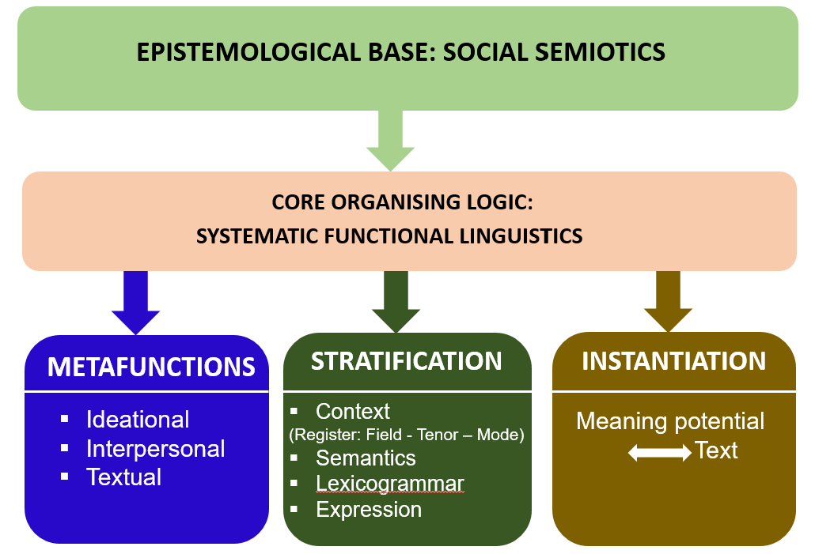
Figure 2.2 Conceptual Framework for the Study

2.7. Concluding Remarks
This chapter establishes the theoretical and empirical basis for analysing EMP textbooks as multimodal pedagogic artefacts. It traces ESP’s shift from register descriptions to discourse and genre perspectives, highlighting EMP as a field where technical language depends on visual and procedural representation. The chapter argues that textbooks mediate knowledge rather than merely contain information, organising pedagogic priorities and learner positioning through design. Grounded in social semiotics, SFL provides a stratified logic for accountable interpretation and extension to multimodality. Reviewing GVD and intersemiotic frameworks, the chapter identifies a persistent gap: EMP research rarely models image-text orchestration systematically, particularly in Vietnam, contexts.

CHAPTER III: RESEARCH METHODOLOGY
Chapter III outlines the study’s methodology for analysing multimodal meaning in Vietnamese-used English medical textbooks. It operationalises a social semiotic paradigm into a qualitative, contrastive corpus design and transparent data selection. The chapter details the staged analytical procedure and Integrated Framework for visual and intersemiotic analysis, and addresses trustworthiness, ethics, and reflexivity.
3.1. Research Design
This study employs a theory-driven qualitative design to examine multimodal meaning in Vietnamese-used English medical textbooks. Using a top-down social-semiotic approach, it compares Medical Terminology: A Living Language and Career Paths: Medical through page-ensemble analysis. Guided by the IMAF, it integrates GVD and Unsworth coding, supported by codebooks, audit trails, and reflexive memos for rigour and transparency.
3.2. Data Corpus
The corpus includes two widely used EMP textbooks in Vietnam, Medical Terminology: A Living Language (Fremgen & Frucht, 2019) and Career Paths: Medical (Evans, Dooley, & Tran, 2012), chosen to represent contrasting pedagogies: terminology-based classification versus contextualised communication. The page ensemble is the unit of analysis, with 40 page ensembles (20 per book) sampled for semiotic salience, pedagogic centrality, and representational diversity.
3.3. Data Selection Criteria
Data selection was treated as a theory-calibrated stage to ensure explanatory, not merely descriptive, analysis. Aligned with the social-semiotic paradigm and the conceptual framework (GVD + multimodal metafunctions), units were included only when image and language were co-designed for a shared pedagogic purpose. Page ensembles were prioritised for GVD diagnostic richness and explicit intersemiotic anchoring across visuals, wording, and layout. Maximum variation sampling ensured pedagogic centrality and semiotic diversity, excluding decorative, text-dominant, or analytically discontinuous pages.
3.4. Data Collection Procedure
Guided by Burns’ (1999) distinction between describing and explaining, data analysis followed a staged workflow from systematic description to theory-constrained interpretation. Phase A applied Kress and van Leeuwen’s (2021) GVD to descriptively code 40 page ensembles for representational, interactive, and compositional meanings (RQ1), supported by digitisation, an inventory matrix, pilot coding (five ensembles), and a calibrated codebook. Phase B then used Unsworth’s (2008) multimodal metafunctions to explain image-text relations (RQ2) in ideational, interpersonal, and textual terms.
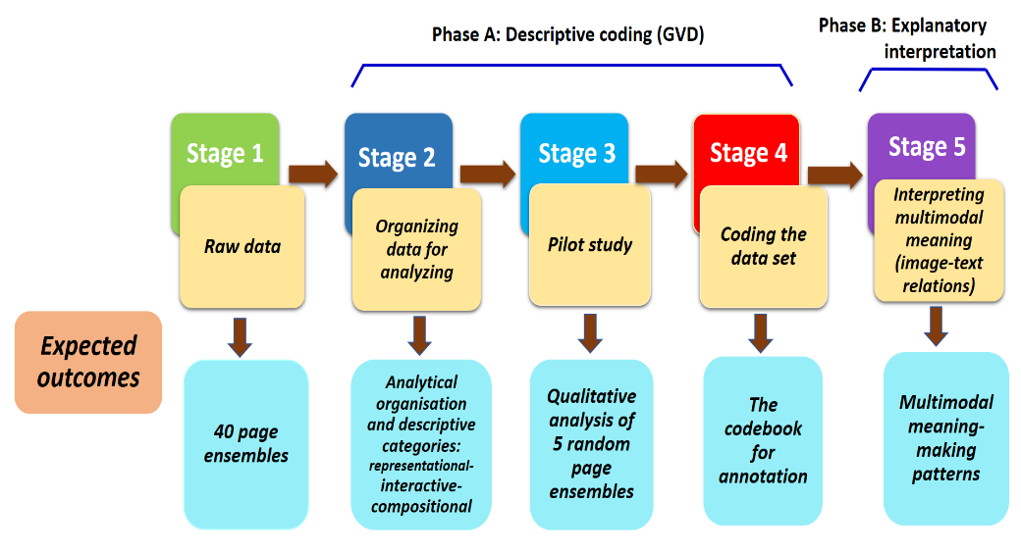
Figure 3.2 Data Analysis Prcocedure
3.5. The Integrated Multimodal Analytical Framework
To explain how visual and linguistic modes jointly construct medical meaning in English medical textbooks used in Vietnam, this study employs an IMAF. Rather than a new theory, the IMAF is a theory-led analytical apparatus that synthesises established social-semiotic models for page-ensemble analysis. It integrates (1) Kress and van Leeuwen’s (2021) Grammar of Visual Design to describe representational, interactive, and compositional visual meanings, and (2) Unsworth’s (2008) multimodal metafunctions and intersemiotic relations to explain image-text coupling. Organised in three strata - visual description, intersemiotic explanation, and pedagogic-disciplinary interpretation - the IMAF ensures systematic, traceable, and auditable analysis.
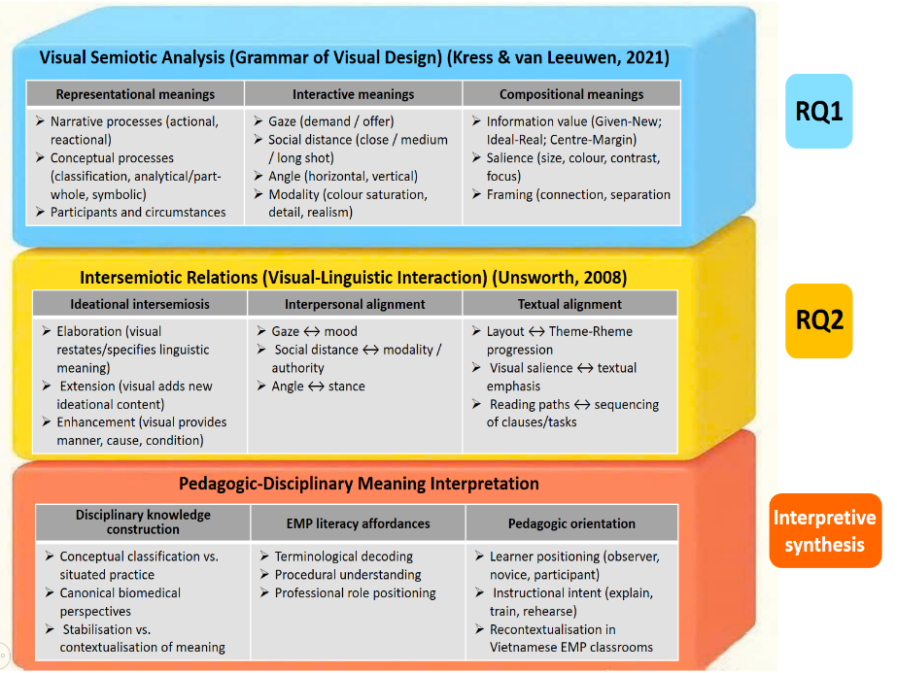
Figure 3.3 Integrated Multimodal Analytical Framework
3.6. Coding and Analytical Phases
Coding in this study is treated as a theory-disciplined interpretive practice aligned with the IMAF, rather than a neutral technical step. The analysis proceeds recursively through three phases. Phase 1 (RQ1) applies GVD to code visual representational, interactive, and compositional meanings, establishing a systematic baseline of visual organisation. Phase 2 (RQ2) codes intersemiotic relations using Unsworth and related typologies, identifying elaboration, extension, enhancement, and metafunctional alignment across image–text ensembles; linguistic features are examined only when they anchor visual meaning. Phase 3 synthesises these findings to interpret pedagogic-disciplinary meanings, explaining how multimodal design constructs medical knowledge and positions learners. Rigour is supported through a rubricised codebook, audit trails, reflexive memos, and a calibrated salience scale (0-3) for consistent comparison.
3.7. Reliability, Validity, and Ethical Considerations
Trustworthiness is ensured through transparent, reflexive multimodal analysis grounded in the IMAF and traceable to corpus evidence (Lincoln & Guba, 1985). Reliability is maintained via consistent coding, audit trails, and memos. Validity is strengthened through cross-stratum triangulation and saturation. Ethical integrity involves accurate attribution, scholarly use, cultural sensitivity, and positionality.
3.8. Concluding Remarks
This chapter establishes a coherent methodological architecture for explaining multimodal meaning-making in English medical textbooks used in Vietnam. Grounded in an interpretive-explanatory social-semiotic paradigm, it operationalises the IMAF as a three-stratum framework, supported by a traceable five-step corpus-building workflow and a rubricised codebook for systematic cross-case comparison between Medical Terminology (MT) and Career Paths: Medical (CPM). It also secures trustworthiness through reflexive consistency, cross-stratum triangulation, saturation logic, and ethical integrity, ensuring that subsequent analyses are theory-constrained, evidence-based, and transparent. On this basis, Chapter IV proceeds to the empirical findings, showing how images and language are designed to co-construct medical knowledge and pedagogic meaning across the selected page ensembles.

CHAPTER IV: VISUAL MEANING IN MEDICAL TEXTBOOK IMAGERY
Chapter IV analyses EMP textbook images as epistemic designs shaping medical knowledge for novice learners. Using IMAF-Stratum 1 and the GVD, it examines representation, viewer positioning, and composition across 40 page ensembles. Findings identify recurring visual mechanisms and establish a visual baseline for Chapter V’s intersemiotic analysis.
4.1. Visual Meaning as Disciplinary Vision: Analytical Orientation and Scope
Chapter IV answers RQ1 by analysing EMP textbook images as epistemic designs (IMAF-Stratum 1), not decoration. Using 40 page ensembles (20 MT, 20 CPM), it compares two visual ecologies: MT’s conceptual, classificatory diagrams and CPM’s contextual, practice-oriented scenes. Guided by GVD and transparent coding, it maps representational, interactive, and compositional meaning to establish visual profiles for Chapter V.
4.2. Distribution of Visual Semiotic Resources across the Corpus
Drawing on the Page-Ensemble Analytical Matrix (Appendix C), this section maps how visual semiotic resources pattern across the 40 ensembles, showing that the contrasts discussed later are design tendencies, not isolated cases. At corpus level, MT and CPM mobilise visuals to foreground different epistemic views of medical knowledge. MT privileges conceptual abstraction-labelled diagrams, cross-sections, and classificatory schemata-inviting learners to inspect, name, and organise the body as a stable system. CPM, in contrast, more often situates meaning in practice, depicting people, tools, and actions in recognisable clinical settings. Viewer positioning and layout reinforce this divide: MT stabilises hierarchy and observation, while CPM supports sequential, task-oriented engagement.
4.3. Representational Meaning in Medical Textbook Imagery
Having established the broader visual tendencies across the corpus, this section turns to representational meaning, the ways textbook images make medical knowledge “seeable” by selecting what is shown, what relations are foregrounded, and which processes are brought into view or left implicit. From a social semiotic perspective, such representational choices are never neutral: they encode disciplinary assumptions about what counts as legitimate medical knowing and how novice learners should access it. Drawing on GVD, the analysis distinguishes conceptual representations, which stabilise classification, part-whole structure, and symbolic identity, from narrative representations, which visualise action, reaction, and temporal unfolding. This distinction is crucial for RQ1 because it reveals contrasting epistemic priorities: MT tends to construct medicine as an abstract, nameable system, whereas CPM more often frames it as situated practice enacted through procedures and interaction.
4.4. Interactive Meaning: Viewer Positioning and Epistemic Relations
Across the 40 page ensembles (Appendix A), interactive meaning is realised through patterned choices of gaze, social distance, angle, and modality that position learners epistemically in relation to medical knowledge. These resources do not merely accompany representation; they shape how knowledge is to be approached. MT predominantly constructs an observer-classifier stance: offer images, neutral angles, and schematic abstraction invite inspection, tracing, and terminological control of canonical biomedical relations. CPM more often produces an apprentice-participant stance: contextual scenes, indirect gaze, eye-level perspectives, and photographic realism draw attention to actions, roles, and interpersonal cues, framing knowing as situated practice. These profiles anticipate Chapter V’s intersemiotic patterns.
4.5. Compositional Meaning and Visual Information Organisation
Across the 40 page ensembles (Appendix A), compositional meaning operates as a key semiotic mechanism for ordering, prioritising, and staging medical knowledge. Within IMAF-Stratum 1, composition is treated as an epistemic resource that guides learners toward what counts as central content, supporting explanation, and pedagogic application. Drawing on GVD, this section focuses on information value, salience, and framing as tools of attention control and meaning hierarchy. Corpus patterns show a stable contrast: MT privileges diagram-centred, ideal-real and centre-margin layouts that stabilise conceptual systems before practice, while CPM favours linear, task-sequenced layouts that distribute meaning across staged activities. These compositional profiles shape reading paths and anticipate Chapter V’s image-text coupling.
4.6. Integrated Visual Meaning Profiles
Drawing on corpus patterns (Appendix C) and traceability evidence (Appendix D), it proposes two stable visual meaning profiles. MT forms a terminological-conceptual regime: conceptual diagrams, offer positioning, neutral viewpoints, and diagram-centred hierarchies construct medicine as a stable, classifiable system, training learners to recognise, label, and organise canonical entities. CPM forms a contextual-professional regime: narrative scenes, workplace realism, and task-sequenced layouts frame medicine as enacted practice, positioning learners as apprentices who interpret actions, roles, and interactional cues. Together, these regimes cultivate contrasting disciplinary visions and anticipate Chapter V’s intersemiotic explanation of image-text coupling.
4.7. Concluding Remarks
Chapter IV answers RQ1 by showing that images in EMP textbooks function as epistemic designs, not decoration. MT privileges conceptual diagrams that stabilise canonical knowledge and position learners as detached observers through strong hierarchy and framing. CPM foregrounds narrative workplace scenes, inviting apprentice-like engagement via task-sequenced, integrated layouts, across 40 ensembles.

CHAPTER V: INTERSEMIOTIC MEANING IN MEDICAL TEXTBOOKS
Chapter V moves from visual meaning to intersemiotic meaning, analysing how images and language are orchestrated within page ensembles to construct medical knowledge. Building on Chapter IV’s visual profiles, it explains how recurring image-text relations stabilise concepts, scaffold procedures, and enact professional roles. Grounded in multimodal social semiotics, the chapter shows how design makes medical knowledge learnable.
5.1. Analytical Orientation and Intersemiotic Scope
Chapter V examines intersemiotic meaning: how images and language work together within page ensembles to construct medical knowledge. Building on Chapter IV’s visual profiles, it treats image-text relations as a designed division of semiotic labour. Using the Intersemiotic Codebook, it analyses 40 ensembles to show how elaboration, extension, enhancement, and projection shape learnable medical knowing.
5.2. Distribution of Intersemiotic Relations across the Corpus
This section maps image-text relations across the 40 page ensembles (Appendix A) to identify which intersemiotic patterns dominate each textbook. Using the Intersemiotic Codebook (Appendix B3) and the corpus matrix (Appendix C), a clear contrast emerges: MT is driven mainly by elaboration, where diagrams are anchored by labels and definitions to stabilise concepts, while CPM favours enhancement and projection, adding procedural context and staging dialogue for role enactment. Although all relation types occur, these tendencies are robust and provide the empirical baseline for deeper analyses in Sections 5.3-5.5.
5.3. Intersemiotic Elaboration and Conceptual Stabilisation
Intersemiotic elaboration links images and text so that one mode restates, specifies, or exemplifies the meaning of the other, helping learners stabilise key concepts and avoid ambiguity (Royce, 2007). In MT, elaboration is pervasive: diagrams, labels, and definitions form a tightly aligned triad that fixes terminology visually and verbally, turning biomedical knowledge into a stable, classifiable system. Images rarely add new story-like content; instead, they make abstract terms concrete while the text constrains interpretation. In CPM, elaboration is used more sparingly and strategically, offering brief conceptual clarification only when needed to support subsequent tasks, procedures, or communicative role enactment.
5.4. Intersemiotic Enhancement and Procedural Meaning-Making
Intersemiotic enhancement builds procedural meaning when images add what the text alone cannot fully show especially sequence, manner, and conditions of action. In MT, enhancement appears but stays tightly controlled: diagrams and cross-sections clarify stages in physiological processes, helping learners follow internal mechanisms while remaining observers rather than agents. In CPM, enhancement is stronger and more central: photos, layout, and task steps work together to show how to do procedures in realistic settings, turning instructions into enactable practice. Overall, MT uses enhancement to explain biology, whereas CPM uses it to scaffold professional action and routine workflow.
5.5. Projection and the Enactment of Professional Roles
Projection builds professional roles by linking who speaks/acts in the text to who is shown in the image, turning dialogue into performable practice. In CPM, projection is strong: speaker labels, scripted turns, and role-play tasks create a rehearsal space where learners move from completing dialogue to enacting workplace talk. Images anchor the scene and make interaction socially plausible. In MT, projection is weaker: tables and definitions name procedures while photos merely witness practice, with little voiced exchange or role attribution. Overall, CPM uses projection to stage participation, whereas MT keeps professional action mainly as observable, terminological knowledge.
5.6. Intersemiotic Density and Cross-Textbook Synthesis
This section synthesises intersemiotic patterns across 40 page ensembles to show how image-text relations cluster into distinct pedagogic logics in the two textbooks. Drawing on Appendix C (relation type and strength) and Appendix D (traceability), intersemiotic density is interpreted as how tightly modes are coupled to stabilise, extend, or enact medical knowledge. The corpus shows a clear asymmetry: MT is densely elaborative, using diagram-label-definition coupling to fix concepts and minimise ambiguity, thus supporting recognition and classification. CPM is more diverse, relying more on enhancement and projection to scaffold procedures and role-based interaction, enabling enactment-oriented learning.
5.7. Emergent Multimodal Pedagogy in Medical English Instruction
Across the 40 page ensembles, two systematic multimodal pedagogies emerge. In MT, dense elaboration (diagram-label-definition coupling) constructs an epistemic pedagogy: knowledge is stabilised as classifiable concepts, and learning foregrounds recognising canonical representations and aligning them with precise terminology. In CPM, enhancement and projection dominate, shaping an enactment-oriented pedagogy: images and layout scaffold sequence, conditions, and professional routines, while dialogues and role labels invite learners to rehearse interaction. Rather than competing, these designs are complementary: one secures conceptual control, the other converts it into procedural and communicative performance in EMP classrooms.
5.8. Concluding Remarks
This chapter shows that medical meaning in EMP textbooks is produced through systematic image-text relations, not isolated modes. Across 40 page ensembles, MT is dominated by elaboration, whereas CPM relies more on enhancement and projection. Epistemically, MT stabilises concepts through tight diagram-label-definition coupling, supporting canonical, classifiable knowledge and terminological precision. CPM, in contrast, uses enhancement to add procedural sequence, manner, and condition, while projection stages dialogue and role attribution, turning knowledge into performable practice. Intersemiotic density reveals emergent multimodal pedagogy: MT supports conceptual consolidation, while CPM scaffolds procedural reasoning and professional enactment.

CHAPTER VI: CONCLUSIONS
This chapter consolidates the thesis’s main insights, integrating findings, theoretical contributions, and implications for Vietnam from a comparative multimodal analysis of two EMP textbook series. It argues that medical meaning is designed through visual and intersemiotic patterns across page ensembles, answers the research questions, notes limitations, and outlines future research agendas.
6.1. Restatement of Research Purpose and Methodological Orientation
This thesis explains how medical meaning and pedagogic orientations are constructed through the visual and intersemiotic design of EMP textbooks used in Vietnam. Treating textbooks as designed multimodal artefacts rather than verbal content with added illustrations, the study argues that medical knowledge is semiotically organised made visible, stabilised, contextualised, and rendered teachable through patterned image-text orchestration. The research questions form a single explanatory sequence: visual meaning is first examined through representational, interactive, and compositional organisation, and is then extended to how language and image jointly realise meaning via intersemiotic relations and metafunctional alignment. Methodologically, the study adopts an interpretive-explanatory qualitative design grounded in multimodal social semiotics and operationalised through the IMAF’s three strata: visual analysis, intersemiotic mapping, and pedagogic-disciplinary interpretation. The page ensemble is used as the unit of analysis to capture distributed semiotic labour across images, labels, tasks, and layout. Rather than evaluating learning outcomes, the thesis identifies design affordances that preconfigure pedagogic possibilities in Vietnamese medical education.
6.2. Summary of Key Findings in Relation to Research Questions
Across both textbook series, the study confirms a core multimodal claim: medical meaning is not located in language or images separately, but emerges through designed orchestration of modes that stabilises knowledge, guides attention, and positions learners. Yet the two books realise this principle through contrasting semiotic regimes. For RQ1, MT foregrounds conceptual, diagrammatic, classificatory visuals that construct medicine as a stable system, whereas CPM privileges contextualised, narrative imagery that frames medicine as situated practice and interaction. For RQ2, MT shows dense elaboration (diagram-label-definition) that secures conceptual precision, while CPM relies more on enhancement and projection to scaffold procedures and rehearse professional roles.
6.3. Theoretical Contributions
This thesis contributes theoretically by showing that EMP textbook meaning is semiotically designed, not simply delivered through “content.” It argues that Medical English materials require an integrated multimodal account because disciplinary knowledge is constructed through visual-verbal orchestration at the page-ensemble level, rather than through language or images in isolation.
First, the study extends multimodal social semiotics into EMP as a medical disciplinary-professional domain, demonstrating that “medical meaning” is realised through two epistemic pathways: conceptual classification (MT) and situated enactment (CPM). This links multimodality directly to disciplinary literacy and professional vision, clarifying that different visual regimes train different ways of knowing medicine.
Second, the thesis demonstrates the explanatory value of the IMAF as a workable integrated framework. By combining GVD-based visual analysis with intersemiotic relation modelling and pedagogic interpretation, the IMAF enables analysis to move from semiotic description → intersemiotic explanation → pedagogic inference in a traceable, theory-constrained way.
Third, the study reconceptualises intersemiotic density/signature as an epistemic indicator of pedagogy. MT’s dense elaboration supports conceptual stabilisation and terminological control, while CPM’s stronger enhancement and projection supports procedural scaffolding and role enactment. This offers a principled bridge between micro-level multimodal patterns and macro-level pedagogic orientations, including in Vietnam’s EMP context.
6.4. Pedagogical Contributions
Pedagogically, this thesis reframes EMP learning as multimodal disciplinary literacy rather than “medical vocabulary plus reading”. It argues that textbooks apprentice students into medical ways of meaning-making: reading diagrams as conceptual systems, interpreting procedures as sequenced and conditional action, and recognising how professional roles are visually staged and made speakable. Instead of claiming learning outcomes, the study identifies semiotic affordances what multimodal design makes learnable and what it demands from teaching in Vietnamese classrooms. It also distinguishes two complementary pedagogies: MT’s elaboration-dense design supports conceptual and terminological stabilisation, while CPM’s enhancement and projection scaffold procedural competence and role-based interaction, together enabling more balanced EMP competence.
6.5. Practical and Institutional Implications for the Vietnamese Context
Pedagogically, this thesis reframes EMP learning as multimodal disciplinary literacy, not simply “vocabulary + reading.” It shows that medical students need to learn how to read diagrams as conceptual systems, follow procedures as sequenced action across modes, and recognise how professional roles are designed and made speakable through image-text orchestration.
The study also identifies two complementary multimodal pedagogies embedded in the textbooks. MT supports an epistemic pedagogy: dense diagram-label-definition coupling stabilises concepts and strengthens terminological classification. CPM supports an enactment-oriented pedagogy: enhancement and projection make procedures and roles performable through task sequencing and dialogue-based scenarios.
Rather than ranking these approaches, the thesis argues that they develop different but equally necessary competencies-conceptual precision versus procedural and interactional competence highlighting the need for principled integration in Vietnamese EMP teaching.
6.6. Limitations of the Study
This study acknowledges several limitations that define the epistemic boundaries within which its claims are valid. First, the corpus comprises 40 page ensembles from two EMP textbook series, which supports comparative, theory-driven interpretation but does not represent EMP materials broadly; findings therefore offer analytic transferability rather than statistical generalisability. Second, the analysis focuses on semiotic affordances embedded in page design, not on classroom uptake or learning outcomes, because multimodal social semiotics distinguishes meaning potential from meaning in use. Third, the results are domain-specific: EMP’s conceptual density, diagrammatic traditions, and risk-sensitive professional discourse mean that identified intersemiotic patterns should not be automatically extended to other ESP fields. Fourth, the framework integration (GVD, intersemiotic complementarity, IMAF) is necessarily selective, since existing models do not fully theorise gradience, sequencing, or epistemic weighting across modes. Finally, multimodal findings remain interpretively mediated; rigour is secured through transparent coding, traceability, and reflexive documentation rather than claims of objectivity.
6.7. Directions for Future Research
Future research should extend this thesis from designed multimodal affordances to classroom enactment and broader, locally grounded EMP ecologies. First, classroom-based studies are needed to examine how teachers and students actually activate page ensembles in real time, how diagrams are pointed to, how tasks are staged, how images are talked into meaning, and how learner roles are shaped through interaction. Second, the field should develop assessment constructs for multimodal medical literacy, targeting not simple “picture description” but the abilities to interpret diagrammatic structures, integrate image-text evidence, reason through procedures, and perform role-based clinical communication. Third, comparative research should contrast imported EMP textbooks with Vietnamese-produced or locally adapted materials to reveal different epistemic assumptions and specify what localisation requires in visual design and task architecture. Finally, longitudinal curriculum studies can trace how conceptual stabilisation and enactment-oriented learning accumulate across programmes, testing how multimodal pedagogies should be sequenced from terminology building to clinical practice.
6.8. Concluding remarks
Taken together, these directions follow a disciplined logic: the thesis has established what multimodal textbook designs afford; subsequent research should demonstrate how those affordances are enacted, assessed, localised, and sequenced. However, the agenda is not merely methodological expansion. More critically, it positions multimodality as an epistemic problem in EMP: how medical knowledge is made learnable through semiotic orchestration, and how Vietnamese institutions can design curricula that develop not only medical vocabulary but also the multimodal literacies required for contemporary biomedical communication (Jewitt, 2014; Kress, 2010; Swales, 2002).
THESIS-RELATED PUBLICATIONS

Pham, B. N. (2022). Interactive meaning of visual images in medical textbooks: A multimodal discourse analysis. In Proceedings of the National Scientific Conference UNC 2022, Vol.1, April 2022, 334-340, Vietnam National University Press, Hanoi, ISBN 978-604-369-216-7.

Pham, B. N. (2022). Towards a multimodal analysis of images in a medical textbook. In VietTESOL International Convention 2021-Rethinking English Language Education in the Covid Era, Vol.2 (2022), 271-279, Vinh University Press, Hanoi, ISBN 978-604-923-665-5. https:// proceedings.viettesol.org.vn/ index.php/vic/issue/view/1

Pham, B. N. (2023). Interactive mode of visual images in a medical textbook: A multimodal discourse analysis. In International Graduate Research Symposium, Vol.1, October 2023, 1113-1122, Vietnam National University Press, Hanoi, ISBN 978-604-384-167-1.

Lam, Q. D., & Pham, B. N. (2024). A multimodal discourse analysis of a medical textbook in Vietnam: Preliminary findings. In VNU Journal of Foreign Studies, 40(3), 21-34, https://doi.org/10.63023/2525-2445/jfs.ulis.5220

Pham, B. N. (2025). A multimodal discourse analysis of visual images in a medical textbook, Journal of Language and Life-Linguistics Society of Vietnam, 3 (365)-2025, 51-58, National Political Publishing House, ISSN 0868-3409.

Pham, B. N. (2025). An analysis of communication modes of visual images in a medical textbook, Journal of Language and Life-Linguistics Society of Vietnam, Vol. 6B (369)-2025, 190-203, National Political Publishing House, ISSN 0868-3409.

Pham, B. N. & Lam, Q. D. (2025). What do the visual images say in a medical textbook?. In International Graduate Research Symposium, Vol.1, March 2025, 908-916, Vietnam National University Press, Hanoi, ISBN 978-604-43-4293-1.

Pham, B. N. & Lam, Q. D. (2025). Deconstructing visual discourse: A multimodal perspective on images in a medical textbook. In Proceedings of the International Scientific Conference-Functional Linguistics and Multimodality, August 2025, 472-482, Vietnam National University Press, Hanoi, ISBN 978-604-43-5199-5.

Pham, B. N. (2025). A multimodal discourse analysis of images in a medical textbook: Representational modes in focus. In Proceedings of the International Conference on Language, Media and Culture (UniC2025.2), September 2025, 357-370, Vietnam National University Press, Hanoi, ISBN 978-604-43-1138-8.

